Chinook Class | Epic Explorers | Summer 1
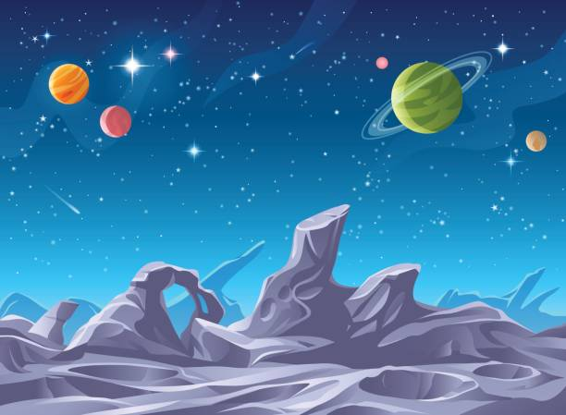
Key Vocabulary |  |  | Key Facts
explorer | Someone who travels somewhere new or unknown to discover more about it. |  | - The Moon has no air, no weather, and no water on its surface.  - Gravity on the Moon is six times weaker, than Earth’s – meaning astronauts bounce as they walk.  - Neil Armstrong became the first man to walk on the Moon on 20 July 1969.  - Ernest Shackleton explored Antarctica and showed great leadership in extreme cold.  - Endurance was the vessel Shackleton used and his expedition is remembered for keeping the whole crew safe.  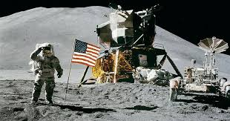  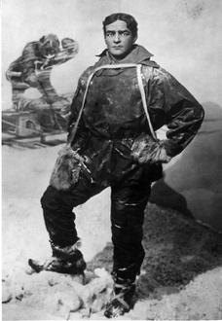  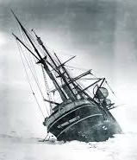  - Their journeys inspired future explorers to keep pushing the limits of what humans can achieve.
astronaut | A person trained to travel and work in space.
expedition | A journey with a particular purpose, often to explore.
adventurer | A person who takes on exciting and sometimes risky journeys.
terrain | The type of land or surface in a place (mountains, craters, deserts)
equipment | Tools and items explorers need to survive and make discoveries.
technology | Machines and tools created to help explorers travel and communicate.
inventor | Someone who designs or builds something new. |  | Key Questions
navigation | Finding your way using maps, landmarks, stars or instruments. |  | - What makes someone an explorer?  - How do Shackleton’s and Armstrongs expeditions compare?  - What challenges do explorers face on Earth vs. in space?  - How does equipment and technology help explorers survive?  - How might exploration change in the future?
survival skills | Abilities that help explorers stay safe in extreme environments

