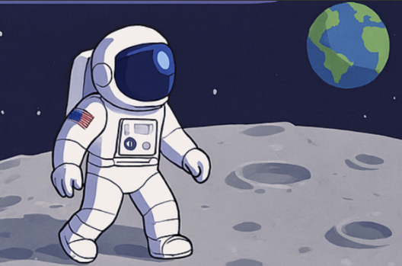
Chinook Class Topic Web
French
Children will learn about towns; how to recognise different buildings and ask for directions, working towards a role-play practicing the vocabulary. They will also be thinking about healthy lifestyles;
talking about food and drink as well as different sports and activities.

PSHCE
Our topic this term is ‘Relationships’. All children will learn about how to make friends and solve problems in friendships when they occur as well as learning what makes a good relationship. Children will learn how to show respect to others and how we can help others feel part of a group or help them and ourselves when we are feeling upset.
Science
Children will be delving into the topic Earth and Space. They will learn about the movement of Earth and other planets, relative to the Sun in our solar system as well as describing the movement of the moon relative to the Earth. Children will also explore the idea of the Earth’s rotation; explaining day and night and the apparent movement of the sun across the sky.

English
This term, children will explore persuasive writing and biography through two fantastic texts: ‘This Rock, That Rock’ and ‘Armstrong: The Tale of a Mouse’. Children will analyse how writers use language to influence and inspire, before crafting their own persuasive pieces with clear viewpoints and strong arguments. Through studying Armstrong, children will examine the features of a biography, learning how to present real-life events in an engaging and informative way. These rich, imaginative books will support pupils in developing their reading comprehension, writing stamina and ability to write for purpose and audience.

Music
Children will continue to learn how to play brass instruments, developing their understanding of posture, and breathing techniques. They will practise reading simple notation, playing together as an ensemble and keeping in time. They will build confidence, control and musical expression.

Maths
Year 6 children will be strengthening understanding of fractions, decimals and percentages. Children will compare, order and convert between these forms, deepen their reasoning skills and apply their knowledge to real-life problems.
In Year 5 children will be learning about shape: measuring, drawing and calculating angles as well as learning regular and irregular polygons and 3D shapes. They will learn position and direction as well as negative numbers.
PSHCE
This term we will be learning all about ‘Healthy Me’. Children in year 4 will explore topics such as smoking, alcohol and personal choice as well as the impact of friendships. Year 5 children will learn about healthy food options and the impact on their bodies before discuss body image.

Computing
This term children will use 2Code. Using the programme children will understand what a function is and how it works in code alongside reading code, predicting outcomes and identifying bugs and fixing them. They will also learn how to simplify code so it easier to read and runs efficiently.
History
We will be looking into the explorations of Armstrong and Shackelton, identifying contrasts and connections between the different time periods. Using a variety of sources such as books, information texts and the internet, children will learn about their achievements. Children will learn about these significant events and the effect it had on the people at the time. Using historical enquiry children will examine evidence and justify conclusions, evaluating the reliability of different sources.

PE
Both Year 5 and 6 will take part in some Commonwealth Games activities learning about lawn bowls and rhythmic gymnastics
Year 5 children will continue with their swimming practice improving strokes and techniques.
Year 6 children will engage in team building activities and exercises, using information given by others to complete tasks, work collaboratively and take responsibility for a role. They will also use their knowledge of PE and physical activities to suggest design ideas & amendments to games.
D&T
This term children will investigate gears, pulleys and levers. They will then research moon buggies, using this knowledge to design a functional final design for them to build and make themselves. Once completed, children will then evaluate their ideas against their design criteria.

