Puma Roaming Romans Summer Term 1
History-Vocabulary
Ancient | From long ago, in the distant past and no longer happening.
Emperor | The ruler of a land- a bit like a King.
Empire | A group of countries ruled over by a single person or country.
Conquer | To take over a place- usually by force.
Legionary | A soldier in a ‘legion’ or group of the army.
Boudica | The name of a queen. She was the leader of the Iceni- a British tribe, who fought against the Romans.

History-Key Facts
The Roman Empire lasted from 700BC to AD476.
At the peak of its power, Rome ruled more than 45 million people across Europe, North Africa and Asia.
Its army was the most powerful in the world.
As it conquered more land, Rome grew from a town into an enormous capital.
The Roman timeline overlaps with the end of the British Iron Age and carries on for around another 400 years (into British Anglo-Saxon Times).

Science – Human Skeleton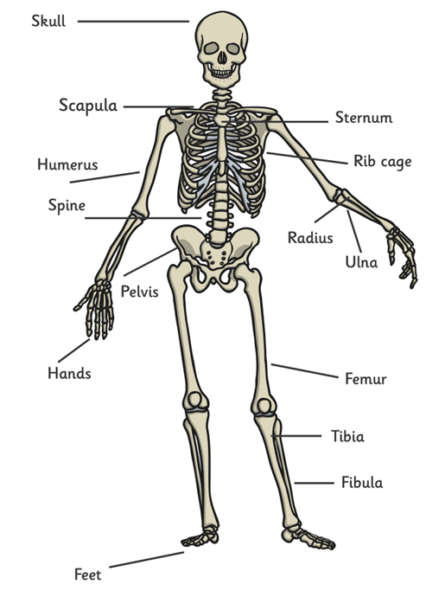

History-Key Questions
How did the Romans get so powerful?

How did they travel around the world?

What impact did they have on modern British life?
Science - Human Nutrition
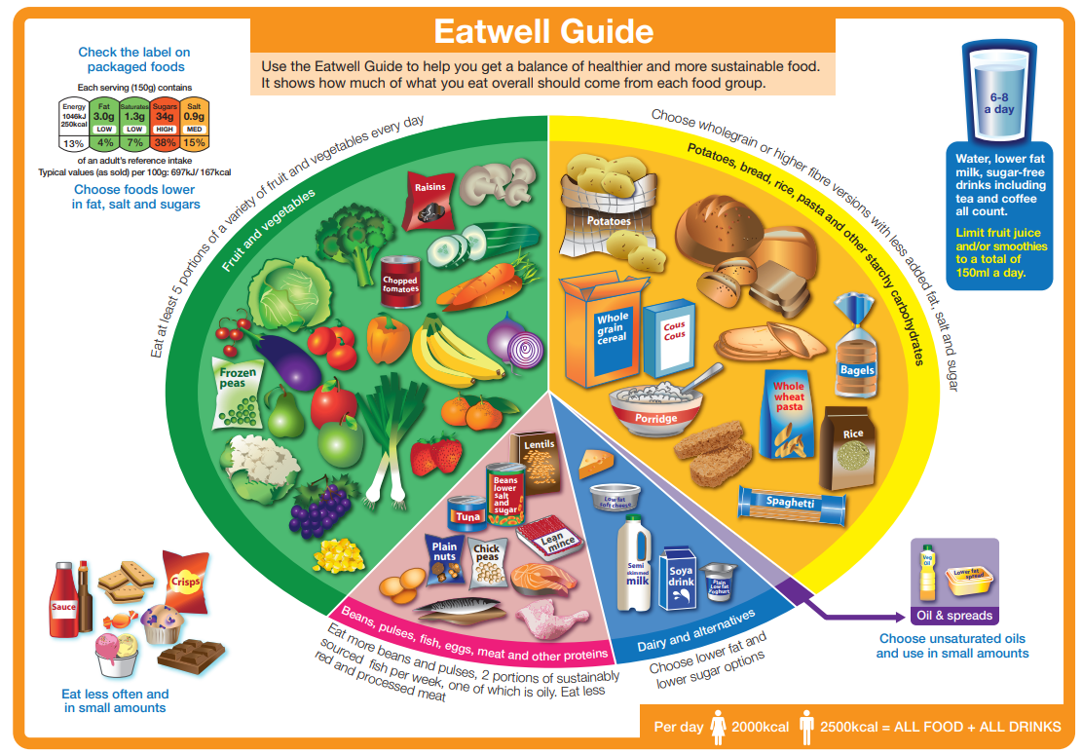

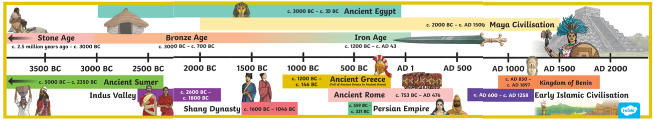
Ancient Civilisations Timeline - revisited

