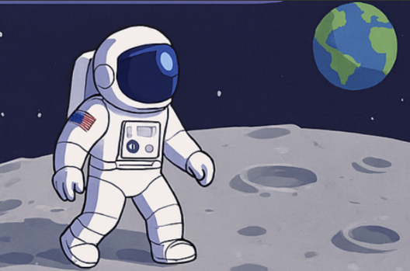
French
Children will learn about towns; how to recognise different buildings and ask for directions, working towards a role-play practicing the vocabulary. They will also be thinking about healthy lifestyles;
talking about food and drink as well as different sports and activities.

PSHCE
Our topic this term is ‘Relationships’. All children will learn about how to make friends and solve problems in friendships when they occur as well as learning what makes a good relationship. Year 4 children will learn how to help themselves or others when they feel upset or hurt, Year 5 children will learn about how to show respect to others and how we can help others feel part of a group.
Merlin Class Topic Web
Science
Children will be delving into the topic Earth and Space. They will learn about the movement of Earth and other planets, relative to the Sun in our solar system as well as describing the movement of the moon relative to the Earth. Children will also explore the idea of the Earth’s rotation; explaining day and night and the apparent movement of the sun across the sky.

English
This term, children will explore biographies. Using Matthew Henson and his famous North Pole exploration as inspiration, children will research him, his explorations and experiences as an African American explorer before writing a biography about him. We will also be delving into the depths of space. Learning how to engage the reader in our writing by using a variety of techniques to immerse the reader, children will write a setting description as if they are an astronaut landing on a new found planet.

Music
Children will continue to learn how to play brass instruments, developing their understanding of posture, and breathing techniques. They will practise reading simple notation, playing together as an ensemble and keeping in time. They will build confidence, control and musical expression.

Maths
Year 4 children will learn to round, order and compare decimals, convert, compare and estimate with money as well as learning analogue and digital time.

In year 5 children will be learning about shape: measuring, drawing and calculating angles as well as learning regular and irregular polygons and 3D shapes. They will learn position and direction as well as negative numbers.
PSHCE
This term we will be learning all about ‘Healthy Me’. Children in year 4 will explore topics such as smoking, alcohol and personal choice as well as the impact of friendships. Year 5 children will learn about healthy food options and the impact on their bodies before discuss body image.

Computing
This term children will use 2Code. Using the programme children will understand what a function is and how it works in code alongside reading code, predicting outcomes and identifying bugs and fixing them. They will also learn how to simplify code so it easier to read and runs efficiently.
History
History
We will be looking into the explorations of Armstrong and Shackelton; identifying contrasts and connections between the different time periods. Using a variety of sources such as books, information texts and the internet, children will learn about their achievements. Children will learn about these significant events and the effect it had on the people at the time. Using historical enquiry children will examine evidence and justify conclusions, evaluating the reliability of different sources.

PE
Dance will be our Year 4 focus this term, learning new skills such as selecting appropriate actions and movements to suit the style of dance, work with others to produce a sequence and interpret other children’s choreography.
Both year 4 and 5 will take part in some Commonwealth Games activities learning about lawn, bowls, rhythmic gymnastics
Year 5 children will continue with their swimming practice improving strokes and techniques.
D&T
This term children will investigate gears, pulleys and levers. They will then research moon buggies, using this knowledge to design a functional final design for them to build and make themselves. Once completed, children will then evaluate their ideas against their design criterias.

