Merlin Class | Epic Explorers | Summer 1
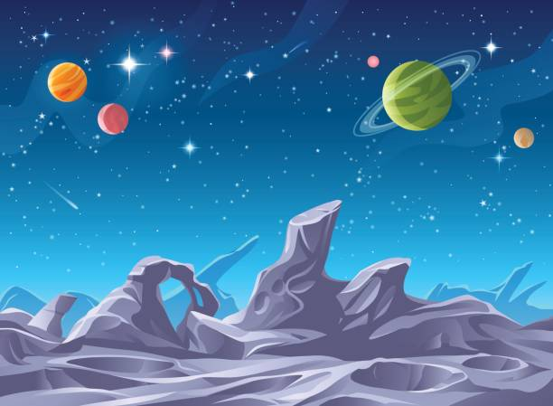
Key Vocabulary |  |  | Key Facts
explorer | Someone who travels somewhere new or unknown to discover more about it. |  | - The Moon has no air, no weather, and no water on its surface.  - Gravity on the Moon is six times weaker, than Earth’s – meaning astronauts bounce as they walk.  - Neil Armstrong became the first man to walk on the Moon on 20 July 1969.  - They travelled in the Apollo 11 spacecraft, made up of the Command Module Columbia and the Lunar Module (Eagle).  - The astronauts wore special spacesuits that provided oxygen, protection and temperature control.  - Armstrong said the famous words: “That’s one small step for man, one giant leap for mankind.”  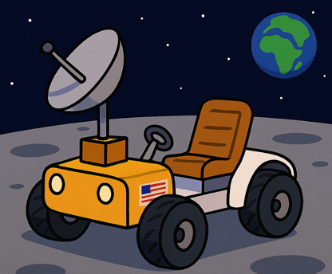  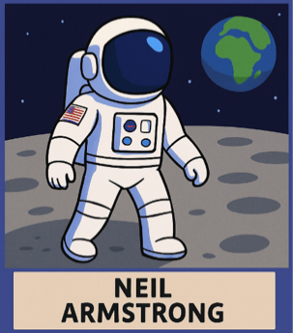  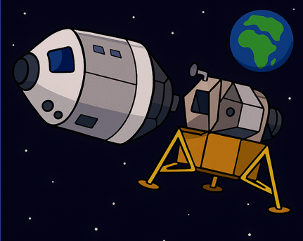
astronaut | A person trained to travel and work in space.
expedition | A journey with a particular purpose, often to explore.
module | A section of a spacecraft with a specific jo (e.g., Lunar Module)
surface | The outside layer of something – the top of the Moon is its surface.
gravity | A force that pulls objects down; the Moon’s gravity is much weaker than Earth’s.
technology | Tools and machines created to solve problems.
inventor | Someone who designs or builds something new. |  | Key Questions
rover/buggy | A vehicle made to explore other worlds. |  | - What makes someone an explorer?  - Why was the Moon landing a turning point in history?  - How does the Moon’s environment challenge explorers?  - How do spacesuits and technology help astronauts?  - How might exploration change in the future?
organism | A journey to very cold regions of Earth, like Antarctica.

