Year 2 Magical Mapping Spring 2
Vocabulary:  city  climate  habitat  harbour  key  season  village | a town created a city by charter and often containing a cathedral  the weather conditions in or over a long period  the natural place where something lives  a place of shelter for boats  a list of symbols that appear on a map  four time periods of the year (spring, summer, autumn, and winter) marked by particular weather patterns and daylight hours  a group of houses and other buildings, in a rural area | 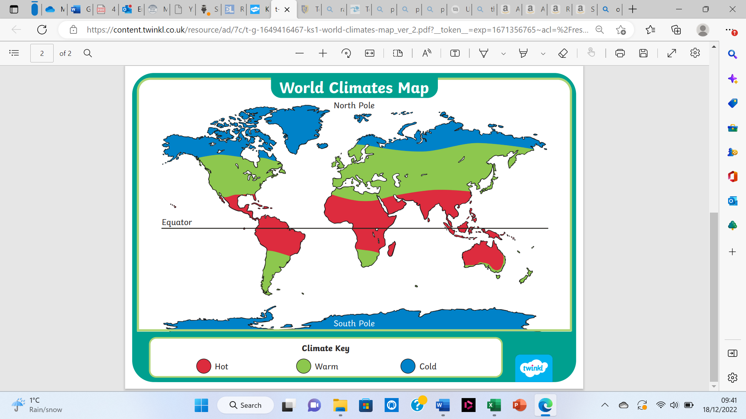 | Match the images to the map symbols.  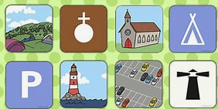
Key Questions:

- Which continent is always cold? Which continent is mostly hot? Why?
- What is the difference between a town and a city?
- What land uses are there in RAF Benson?

Key Facts:

- The equator is a line mapped onto Earth equidistant from the poles, which divides Earth into northern and southern hemispheres.
- Polar deserts are located at the Earth’s poles. The Arctic desert is located at the North Pole, and the Antarctic desert at the South Pole.
- There are 76 cities in the United Kingdom, including 6 new cities granted this status during the Queen’s Jubilee in May 2022.
Ordnance Survey was founded on 21 June 1791, though the first map took ten years to publish. It covered the area of Kent and focused on communication routes, including hill shading to ensure men at arms could interpret the landscape with precision. Over time, this map design became less focused on these elements and was developed to appeal to a much wider audience. It was thought that 50 years would be long enough to map the UK, but the entire first series of maps took closer to 80 years to finish and weren’t published until 1870!

The Beginning Of Our Paper Maps | Blog | OS (ordnancesurvey.co.uk)

