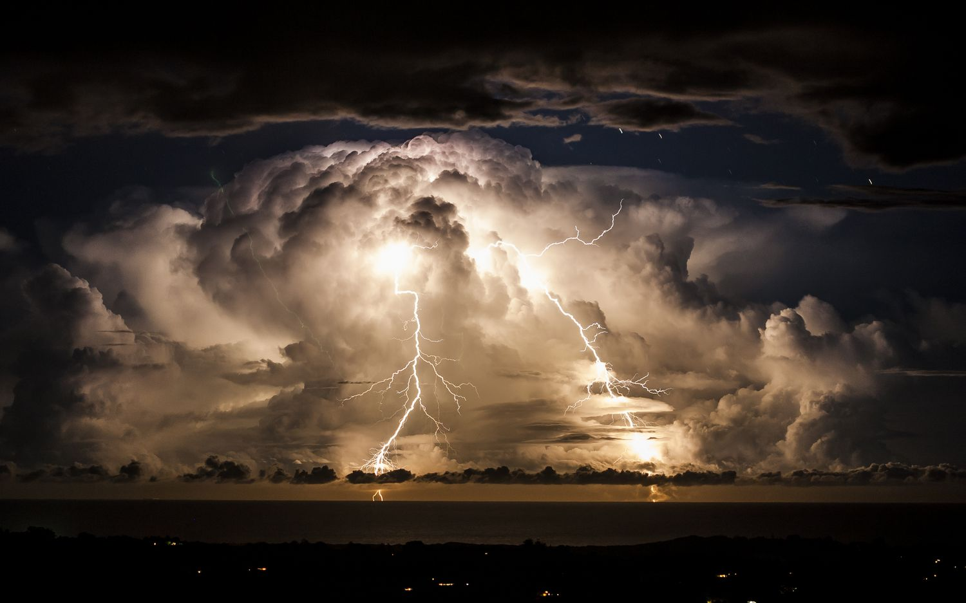
Lynx Class Wild Weather Spring 2
Key Facts: Weather Symbols |  |  |  | 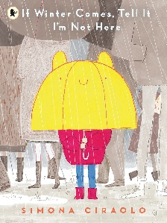  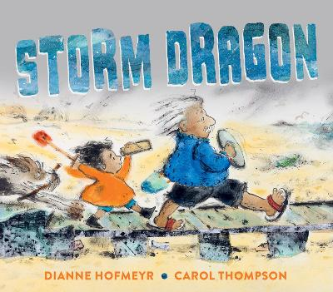  Key Texts  If Winter comes, tell it I am not here by Simona Ciraolo  Storm Dragon by Dianne Hofmeyr
  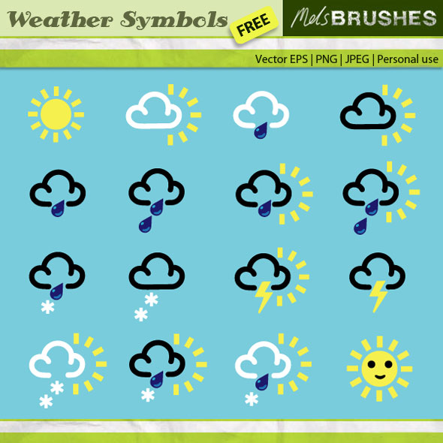 |  |  |  | 
  Sun | Rain | Snow | Cloud | Fog | Storm
Science: Seasons  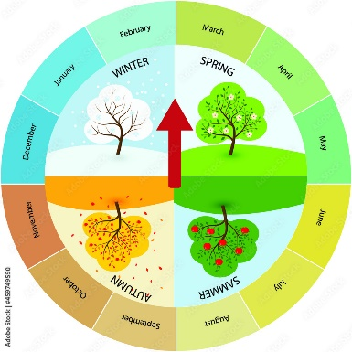 |   Earth Trust  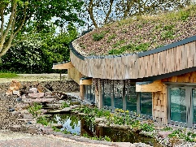  This term, we will be going on a visit to Earth Trust. We will learn all about where different animals come from, explore their forest school area and complete workshops on weather. | Our Artists  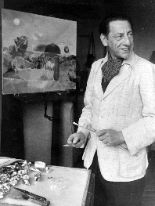  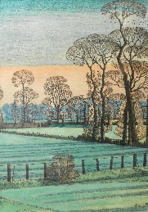  This term, we will be comparing two artists who both paint the weather.    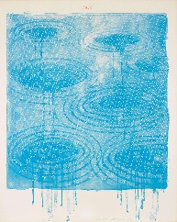  Paul Nash was a British painter. He painted lots of things including some battles in WW1. He also painted Wittenham Clumps, which is only 10 minutes from Benson!  David Hockney was born in Bradford, that’s where Mrs Free is from. He is famous for painting landscapes of Yorkshire and portraits of people. He also painted a group of photos of the weather for his Weather series.
Key Vocabulary  Autumn: September, October, November, when leaves fall of trees and the days begin to get shorter.  Horizon: The line where the sky looks like it meets the Earth or sea.  Season: a season is one of four parts of the year that has its own special weather, temperature and daylight.  Spring: March, April, May, the temperature starts to get warmer and things begin to grow.  Summer: June, July, August, the warmest season of the year, there are lots of daylight hours.  Sunrise: Happens in the morning when the sun first appears over the horizon.  Sunset: Happens in the evening when the sun goes below the horizon.  Weather: What the air and sky are like outside each day.  Winter: December, January, February, the coldest season where the days are shortest. |  |  | Key questions  -What are the names of the four seasons?  -Which months are in each season?  -What is the difference between the length of the daylight in summer and winter?  -What differences are there between cold and hot places?  -How can we record weather?  -How do we measure how hot or cold something is? |  | 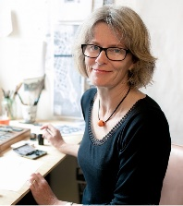  World Book Day  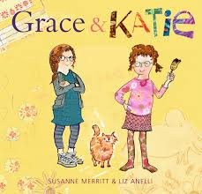  This term we will be celebrating World Book Day on Thursday 5th March. We are very excited to be welcoming children’s book illustrator Liz Anellii into class to work with us on our own illustrations. Liz has been making up stories since she was little and she recently won the 2025 Shirley Hughes sketchbook prize.

