Lynx Class Fab Fiji Spring 1
Key questions  -What countries make up the UK and what are their capital cities?  -Where is Fiji and what is it like there?  -How is where we live different from Fiji?  -What physical and human features are their where we live and in Fiji?  -How can we use symbols to represent places on a map?  -What are the different parts of a plant and what are their jobs? |  | 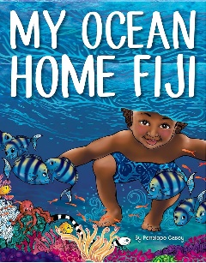  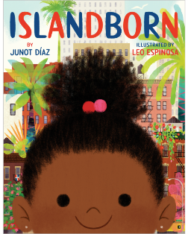  Key Texts  The Big Book of Fiji Facts by James K. Mahi  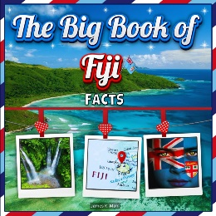  Islandborn by Junot Diaz  My Ocean Home Fiji by Penelope Casey
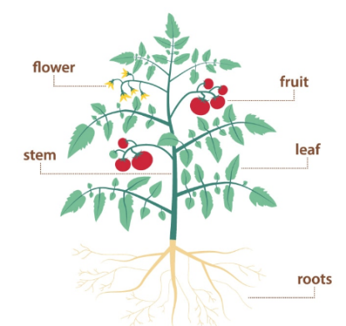  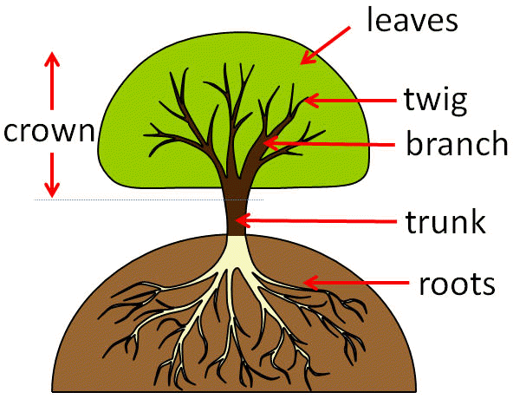  Science: Plants  Parts of flowering plants  Parts of trees | 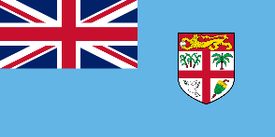  Key Facts:  -Fiji is in the southern Pacific Ocean.  -Fiji is made up of 332 islands.  -The largest island of Fiji is called Viti Levu.  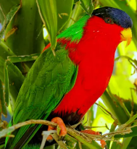  -Fiji’s islands have lots of forests and mountains.  -The capital city is called Suva.  -The national symbol is the Fijian canoe and the national colour is light blue.  -The Collared Lory is the national bird of Fiji. |  |  | Countries and Capital Cities of the UK  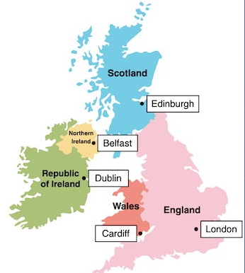
Key Vocabulary  Country: piece of land with its own rules (government), leaders, and borders, where people often share language and culture.  Capital city: a special city chosen by the government or royals of a country. A capital city is often where the main government offices and meeting places are located.  Environment: everything around us.  Differences: the ways in which something is not the same as something else.  Human features: things like houses, roads and bridges. They have been built by people.  Map: a drawing of an area, they can be used to help people plan a journey or find something.  Physical features: seas, mountains and rivers are natural. They would be here even if there were no people around.  Similarities: things that are alike in some way or ways. |  |  | 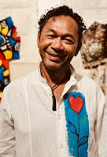  Significant people:  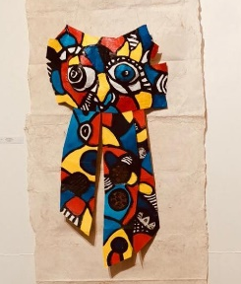  Lambert Ho is a Fijian Artist whose work includes painting, fabric art for fashion shows, contemporary jewellery using natural local materials and visual art. He decided he wanted to be an artist when he was 15 years old and then got a scholarship to art school. He doesn’t have a studio; he likes to wonder and create art wherever he goes. He says that his art is colourful with messages of love, peace and joy. He likes Vicent Van Gogh’s art, this is an artist our Year 1’s will recognise from last year.


