Year 1 Land vs Sea Summer 2
Key Vocabulary  - Coast- The part of land near the sea.  - Beach- A strip of land covered in sand or stones at the edge of a body of water.  - Sea- a smaller portion of the ocean most often met by land in some way.  - Ocean- expanse of salt water that covers most of the earth's surface.  - Cliff- a steep rock face, especially at the edge of the sea.  - Predator – an animal that preys on others. | Sharks  Sharks are the apex predator of the seas. There are over 300 species of shark in the world and most of them like to live in the warm oceans. | Key Questions:  - Why are sea animals important?  - What oceans do sharks live in?  - What predators can be found in the ocean?  - What is the difference between the sea and an ocean?
How to make Ice lollies.
- In a bowl, blend fruit and vegetables. Stir in any whole fruit and fruit juices.

- Divide the mixture equally between your lollipop moulds. Cover with foil.
- Freeze the ice lollies overnight.

Our Coastline  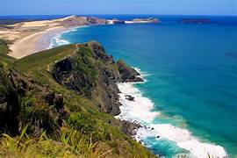  Sea  Cliff  Beach  Coast |  | 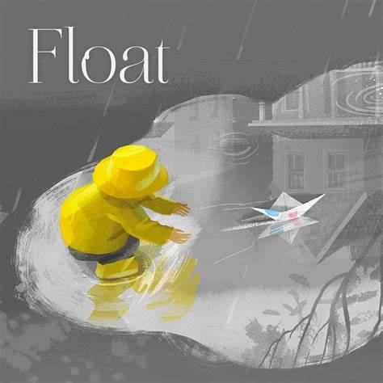  Class Texts  Float by  Daniel Miyares  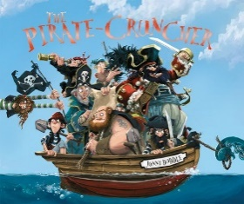  The Pirate Cruncher by Jonny Duddle

