Year 1 Terrific Toys Spring 2
Key Vocabulary  - Past- Something that has happened.  - Present- Period of time that is happening now.  - 20th Century- The 20th Century was from 1900-1999.  - 21st Century- We are in the 21st Century. It started in the year 2000.  - Wood- Toys used to be made from wood boats and train sets.  - Metal- In the 20th Century Toys like soldiers and spinning tops were made from metal.  - Plastic- A new material that modern toys are made from.  - Lego- A popular toy from the late 20th Century.  - Electronic toys- A toy that requires a form of computer or power to work. | 20th Century Toys  - Wooden dolls  - Wooden dolls houses.  - Ball and cup.  - Spinning tops  - Toy soldiers | 21st Century Toys  - Plastic dolls (Action man/ Barbies)  - Electronic games  - Lego/Mecano  - Computers  - Games consoles
 | Key Questions:  How long have toys existed for?  What are modern toys made of?  When was Lego first created? | Key Facts:  - The first ever toy was a ball, it was made from clay.  - The teddy bear was named after American president Theodore Roosevelt.  - Toys used to be made from stone, clay and metal.
 | Common Toys  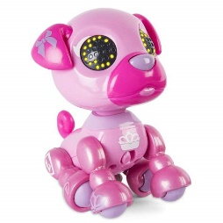  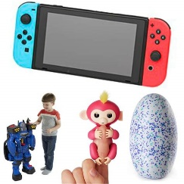  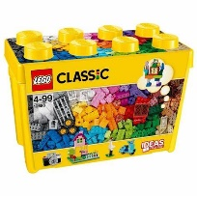 | Class Text  

