Griffin Class Magnificent Monarchs Autumn 1
Key Vocabulary  Royal- having the status of a king or queen or member of their family.  Queen- a female ruler of an independent state.  Monarch- a sovereign head of state especially a king or queen.  Reign- to hold royal office.  Victorian Era- the period when Queen Victoria reigned.  Chronological- the time order when things happen. |  | Key Questions  Who is Queen Victoria and Queen Elizabeth II?  Who had the longest reign?  Who was the youngest when they became queen?  Key Facts  - It’s the largest inhabited castle in the world.  - King Charles III currently resides there.  - It was Queen Elizabeth II favourite castle.
Windsor Castle  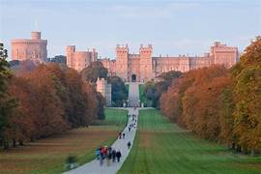  Windsor castle is in the royal county of Berkshire. It was built in 1070 although many kings and queens have changed it since then. Queen Victoria used it as her main home during her reign whilst Queen Elizabeth II was brough up there as a little girl; In 1992 there was a great fire at Windsor castle, and it took 5 years to fix the damage. Windsor is the largest and oldest occupied castle in the world. |  |  | 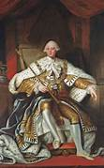  Joshua Reynolds  Joshua Reynolds was a famous portrait painter. He was known for being able to capture different facial expressions on the people he was painting. He painted King George III in 1780.
Key Texts  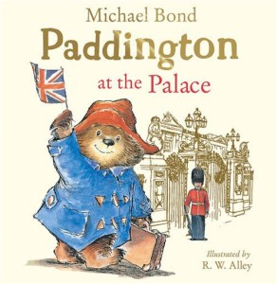 | 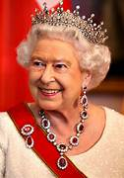  Significant People  Queen Elizabeth II  1926-2022  Queen Victoria  1819-1901  

