Year 1 Wild Weather Spring 1
Key Vocabulary:  Seasons – There are four season’s in each year, spring, summer, autumn and winter.  Spring – The season after winter and before summer.  Summer – The season after spring and before autumn.  Autumn – The season after summer and before winter.  Winter - The season after autumn and before spring.  Weather – Daily changes in the atmosphere which include temperature, wind direction and strength, rain, cloud, snow and sun.  Temperature - How warm or cold something is.  Wind - Air moving across the Earth’s surface.  Cloud – Collections of tiny water droplets floating in the air.  Rain – Water that falls from clouds.  Snow - Small, soft ice that falls from clouds when it is cold.  Storm – A type of weather with strong winds and heavy rain.  Fog – Very low cloud. | Seasons:
  Spring – March, April, May  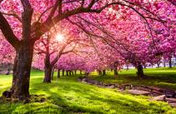  The weather starts to get warmer after winter and days get longer.  Baby animals are born and flowers bloom. | Summer- June, July, August  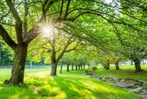  Summer is the warmest season and plants have lots of leaves.  The length of the daylight hours is longer.
  Autumn – September, October, November  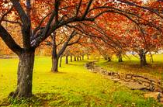  The weather starts to get cooler and days get shorter.  Leaves on deciduous trees turn brown and fall off. | Winter- December, January, February  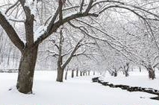  Winter is the coldest season.  Deciduous trees have no leaves and some animals hibernate.
Key questions:
Can you name the four seasons?
Do you know what the weather is like in each season?
What should you wear in each season?
Do you know what months are in each season?
What is the difference between the length of the daylight in summer and winter?
Weather symbols:
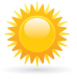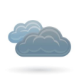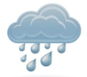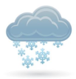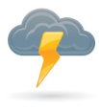
Sunny Cloudy Rainy Snowy Stormy Windy

