Year 1 Groovy Growth Summer 1
Key Vocabulary:  Branches - parts that grow out from the tree trunk and have leaves, flowers, or fruit growing on them  Bulb - a root shaped like an onion that grows into a flower or plant  Deciduous - a tree that loses its leaves in the autumn every year Evergreen - a tree or bush which has green leaves all the year round  Flower - the part of a plant which is often brightly coloured and grows at the end of a stem  Fruit - something which grows on a tree or bush and which contains seeds or a stone covered by a substance that you can eat  Leaf / leaves - the parts of a tree or plant that are flat, thin, and usually green  Petal - thin coloured or white parts which form part of the flower  Plant - a living thing that grows in the earth and has a stem, leaves, and roots  Roots - the parts of a plant that grow under the ground  Seed - the small, hard part from which a new plant grows  Stem - the thin, upright part of a plant on which the flowers and leaves grow  Tree - a tall plant that has a hard trunk, branches, and leaves trunk the large main stem from which the branches grow  Vegetable - plants such as cabbages, potatoes, and onions which you can cook and eat | Parts of flowering plants:  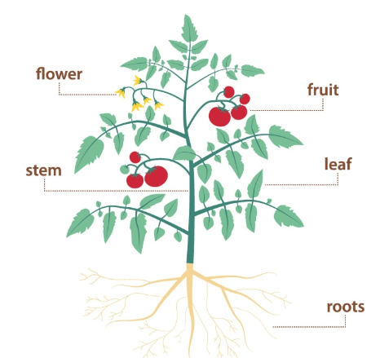 | Parts of trees:  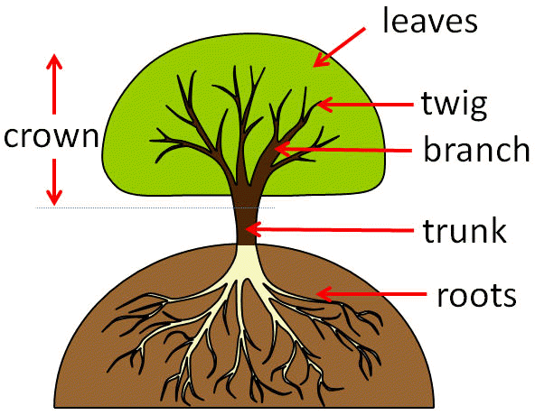
Key questions:

What are the different parts of a plant for?
What parts of plants to we eat?
What is the difference between deciduous and evergreen trees?
 | Common garden plants:  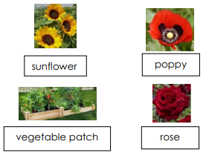  Rose  Vegetable Patch  Poppy  Sunflower | Common wild plants:  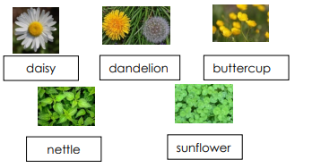  Clover  Nettle  Buttercup  Dandelion  Daisy  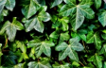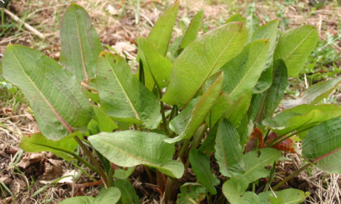  Ivy  Dock

