Lynx Class Toys Over Time Autumn 2
Key questions  -How have toys changed over time?  -What did my parents/ grandparents get for Christmas as a child?  -How could I find out more information about toys in the past?  -What materials are good for making different toys? | 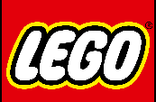  Significant people: Ole Kirk Christiansen  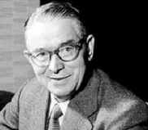  Ole was from Denmark, he grew up in a poor family and he started worked as a carpenter. In 1932, he founded the Lego company. At first, he started to make toys like yo-yos and trucks out of wood. In 1949, he made his first plastic toy called a Binding Brick, which in 1958 became the famous Lego brick. |  |  |  | Key Facts:  -The first ever toy was a ball, it was made from clay.  - There are over 600 billion pieces of Lego in the world.  -The teddy bear was named after American president Theodore Roosevelt.
Science: Properties of Materials  Waterproof: a waterproof material does not allow water to soak through it. It keeps the water out.  Flexible: flexible materials are bendy and not stiff. They can be bent easily without breaking.  Transparent: a material that you can see through a material. For example, glass.  Strong: a material that doesn’t break easily.  Texture: how a material feels. For example, soft or rough. |  |  | 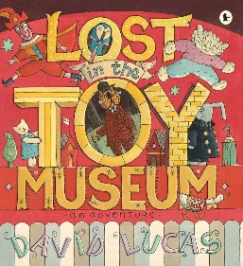  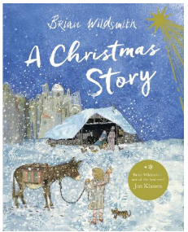  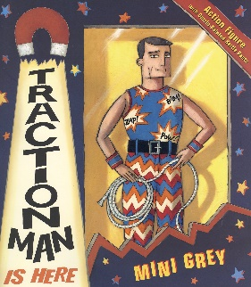  Key Texts  Lost in the Toy Museum by David Lucas  A Christmas Story by Brian Wildsmith  Traction Man by Mini Grey
Key Vocabulary  Electronic Toys: a toy that needs a form of power to work.  Fabric: made from plants, animals or man-made.  Interview: where a person asks somebody else questions to find out information.  Metals: made from natural things mined from underground, some are magnetic.  Past: something that has happened.  Plastic: made from man-made chemicals.  Present: a period of time that is happening now.  Toy: an object for a child to play with.  Wood: comes from trees.  20th Century: the 20th century was from 1900-1999  21st Century: we are in the 21st century. It started in 2000. |  | Significant Event:  Remembrance      Remembrance Day happens on the 11th of November. This is when people remember the men and women who have died whilst serving our country. Paul Cummins is an artist who created the 888,246 poppies as part of a piece of artwork for Remembrance day. |  | Toys from the past:  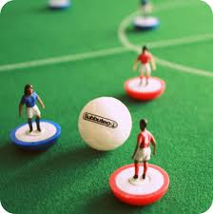  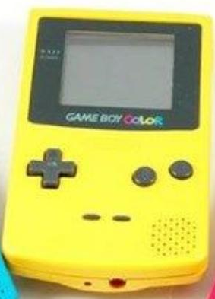  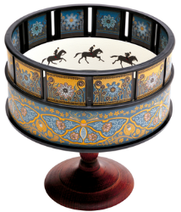  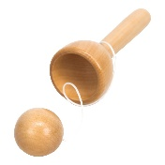  Here are some images of toys from the past. Can you guess what they were called and how they were used?  

