Lynx Class Historical Heroes Autumn 1
Key Questions:  1. Who helps to look after me and keep me safe?  2. Who achieved amazing things in the past?  3. How do we order historical events and people?  4. How can we be heroes for the environment today?  5. What are our 5 senses and what body parts do they link too?  6. How can different animals be classified? | Science: Animals Including Humans  Reptiles: cold-blooded animals with a backbone, usually with dry scaley skin.  Amphibians: cold-blooded animals that have a backbone and no hair or fur. They hatch in water and live on land and in water.  Birds: Warm-blooded animals that have feathers and a beak. They lay hard shells.  Mammals: Warm-blooded with a backbone, hair or fur and have live young. |  |  | Key Facts:  1. Not all birds can fly.  2. A vertebrate is an animal who has a backbone inside its body.  3. In the past lifeboats where not powered by engines but were rowed.  4. The Battle of Britian happened in 1940.  5. We can plot events and the lives of people on timelines using dates.
Super Artists:  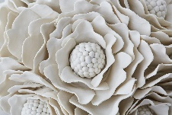  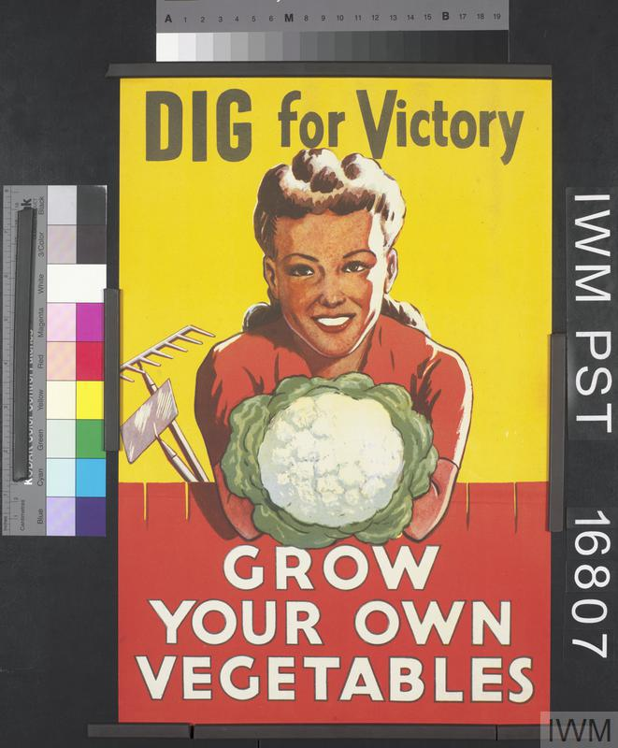  Battle of Britain: Dig for Victory posters. During the war, people there was a shortage of food. Posters were made to encourage people to grow their own.  Vanessa Hogge loves flowers and nature, so she creates sculptures out of clay. Just like flowers, every one of her sculptures are different. |  |  | 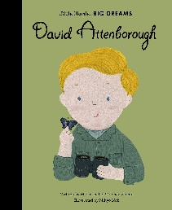  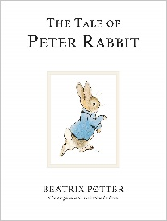  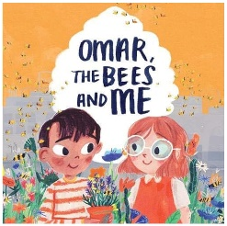  Key Texts  Little People, Big Dreams: David Attenborough by Maria Vegara.  Omar, The Bees and Me by Helen Mortimer.  The Tale of Peter Rabbit by Beatrix Potter.
Key Vocabulary  Author: A person who writes a book or story.  Battle of Britian: An important battle in WW2 where the RAF fought to protect Britain from bombs.  Carnivores: An animal that eats other animals.  Conservationist: A person who tries to protect animals, wildlife and the environment.  Environment: The things that surround us and make up where we are.  Herbivores: Animals that just eat plants.  History: Something that has already happened.  Illustrator: A person who creates pictures to explain a book or story.  Omnivores: Animals that eat other animals and plants.  RNLI: A charity that save people who get into danger at sea.  Sculpture: A type of art that is 3D, it has height width and length. |  | 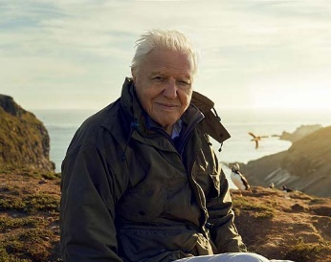  Significant People: normal people can be heroes too.  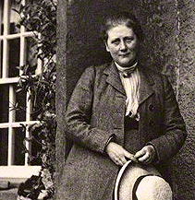  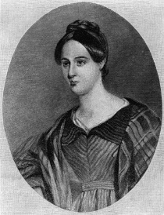  Sir David Attenborough has a passion for protecting animals and nature. He makes nature documentaries to show people our amazing world.  Grace Darling was a hero who rowed a wooden rowing boat to save 9 people from a shipwreck in a storm.  Beatrix Potter a famous author, who loved animals and wrote many stories about them. She also worked to protect nature.

