Maths
We will recap and then extend addition and subtraction, working with two two-digit numbers, using objects and models to help us solve problems and compare number sentences.
We will continue to learn and become automatic in our knowledge of number bonds and times tables (2x, 5x, 10x), before changing our focus to 2d and 3d shape, including lines of symmetry.

English
This term we become historians, learning from non- fiction texts on the Great Fire of London and a fictional recount, “Vlad and the Great Fire of London”, by Kate Cunningham. We will write poetry describing the fire, before retelling the events of the three days as they developed, in a newspaper report. We will continue to develop our grammar skills including use of suffixes -ment, -ness and -less, and use of the progressive forms of verbs in the present and past tense.

PE
This term we continue our ‘Send and Return’ PE focus, we will begin to track the path of a ball over a net and move towards it, with the aim of hitting and returning the ball with some accuracy. In dance, we will apply facial expressions to music showing emotions such as fear and anger and begin to use spatial and dynamic choices in work.

Design and Technology
We will observe and evaluate fire engine designs over time to create a working specification, before planning and making a model of our own. During construction, we will apply existing skills to join elements of our model, whilst extending our skills to using wheels and axels to create a moving vehicle.

RE
This term we discuss the significance of Christmas and how Christians believe that Jesus was a gift from God. Our Key Question is: Why do Christians believe that God gave Jesus to the World?

Gazelle Class Autumn 2
Fire! Fire!

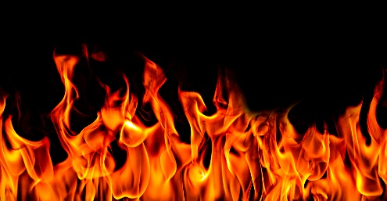

Science
Within the topic of ‘Uses of Everyday Materials’, we will compare the suitability of everyday materials such as wood, metal, plastic, glass and paper for particular purposes, and look at how the shapes of solid objects made from some materials can be changed by squashing, bending, twisting and stretching.
Computing
The children will explore digital art creation using a digital art tool. They will learn about famous art styles and how a digital art tool can be used to reproduce art in that style.

History
This term we be looking back in time to 1666, to study the Great Fire of London, creating a timeline of events and using it to compare life then and now. We will look at contributing factors such as the use of fire, construction of buildings and the methods used to tackle fires and discuss how these affected the outcome of the Great Fire. On our journey, we will also consider the impact significant people such as King Charles II and Samuel Pepys had on London at the time and as we know it now.

PSHE
Our theme this term is ‘Celebrating Differences’, within which we will explore stereotypes and differences between boys and girls, whilst accepting that everyone is different. We will also explore what bullying is, how to help if someone if being bullied and standing up for ourselves,

Music
Based around five of the movements from the ‘Carnival of the Animals’, pupils will explore ways that the composer – Camille Saint-Saëns – has used instruments, rhythm, articulation, tempo, and pitch to create pictures of the animals in our imaginations. We will also be learning our Nativity songs!

