Year 2 Fire! Fire! Autumn 2
Key Vocabulary  - Bakery- A shop here bread is sold.  - Firebreak- A strip of open space that a fire can does not burn.  - Rebuilt- Building something again after it has been broken.  - River Thames- The river that runs through the middle of London.  - 17th Century- From the year 1601 to 1700. The great fire of London happened in the 17th Century. |  | 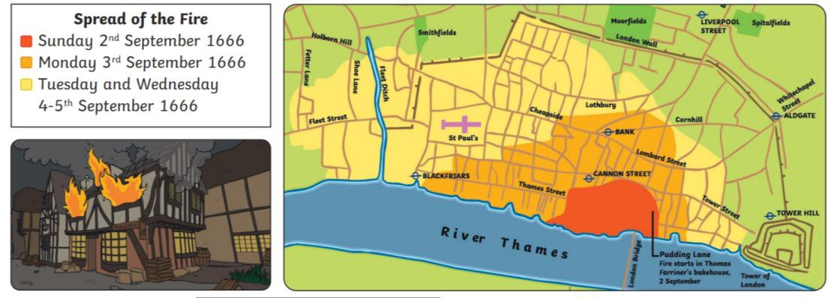
- King Charles II – 1630 – 1685. Charles II became King of England, Scotland and Ireland in 1649, He organised firefighting teams during the Great Fire and took the decision to quickly demolish buildings to create a fire break.
- Samuel Pepys – 1633 – 1703. Samuel Pepys rose through the ranks of the Navy and became Chief Secretary to the Admiralty. His diary gives a first-hand account of many important events of the time, including the Great Plague and the Great Fire of London.
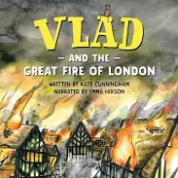  Key Texts | Key Facts:  • The Great Fire of London raged for four days in 1666, destroying much of the city and leaving some 100,000 people homeless.  • After the fire, many buildings were rebuilt. King Charles ll ordered that buildings were built further apart and made of stone to make sure the fire could not happen again so easily. |  | Key Questions:  - When did the great fire of London start?  - Why did the fire spread so quickly?  - How was the fire put out?  - When was the London Fire Brigade formed?

