Year 2 Once upon a time Autumn 1
Key Vocabulary  - Author- a writer of a book.  - Biography- an account of someone’s life written by another person.  - Chronological- in the order in time that it happened.  - Offspring- the young of an animal or a person’s child.  - Nutrition- a way of getting food required for health and growth.  - Hygiene – a way to maintain health through cleanliness. | Key Questions:  - What is an author?  - Who was Roald Dahl?  - What did Roald Dahl live?  - Where does our food come from?  - How can we stay healthy?
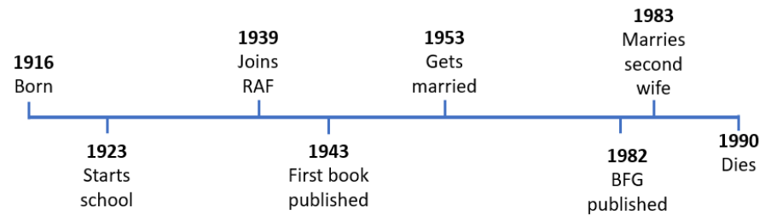
Roald Dahl
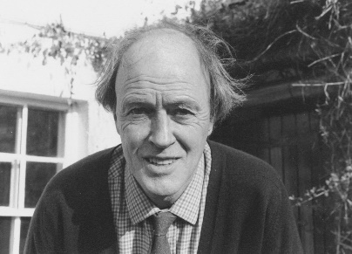
Key Texts
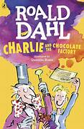
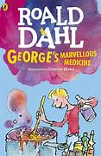
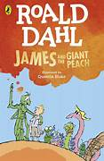
1981: Roald Dahl kept many animals including a goat named Alma and a pony called Jack Frost, which are named in this book:
1964: Roald Dahl had the idea for the story after he was sent chocolate to taste test when he was at school.
1961: Roald Dahl had the idea for the story after observing fruit growing on the trees in his garden in Great Missenden.

