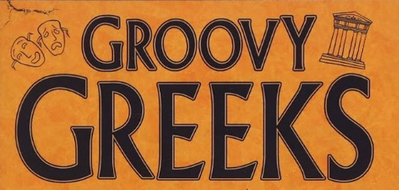
Merlin Class Topic Web
French
Children will have French lessons this term with Madame Whitty. In year 4, the children will learn about habitats, presenting myself and phonics.
In Year 5, they will be learning to talk about…at the café, phonetics, counting to 60 and The Olympics?

PE
All children learn to build a sequence of moves in gymnastics, compare performances and chose a component for improvement.
In PE, Year 4 children will be developing their football skills. They will be able to show basic ball control as well as sending the ball with accuracy with to build an attack.
In year 5 they will practice swimming strokes and learn water safety.
English
This term, children will be looking at famous Greek myths. We will choose one to look at closely, as we unpick the features, structure and language. Children will then use their learning to plan and write their own Greek myth, using the moral from the story in their own piece of writing.

Children will then look deeper at these famous stories, using the book ‘The boy who cried horse’. Children will use this to provide direct and reported quotes for a newspaper recount about the invasion.

Throughout both learning journeys, children will continue to develop their spelling, punctuation and grammar skills, as they develop maturity in their writing. Guided reading sessions will happen daily.

Computing
This term children will continue to develop their computer coding skills. They will then extend their knowledge of databases, creating their own as well as querying existing databases to find information that they are being asked for.

PSHCE
Our ‘Being Me’ unit will help us to reflect on our rights and responsibilities as a citizen of our community and school. Year 6 will also learn about being a global citizen and the power of democracy.

Music
Year 4 and 5 will be enjoying Brass lessons this term with an external music teacher. With his expertise, they will learn breathing and finger techniques essential to playing their instruments effectively.

History
We will be travelling back to the time of the Ancient Greeks, linking all our learning this term to this historical era. We will learn when and where the Ancient Greeks lived, how they lived, what they believed in and the many influences they had on to modern world. We will be learning creatively using our art, engineering, geography, sporting and computer skills to bring this topic to life. We are hoping to have a dress up Greek Day, (get the white bed sheets ready for togas!) and to invite parents in to take part in our very own Olympics, so limber up!

Art
Children will be combining their papier mâché, clay and paining skills this term as they turn their hand to Ancient Greek pottery. As the examine artefacts, they will identify what patterns and images were used on Ancient Greek pots and why. They will then design and make their own pot, considering the shape and purpose before painting it with their chosen design in the classic orange and black style.

Maths
Year 4 will be developing their place value knowledge to 10,000, placing numbers on a number line. They will also look at rounding, ordering and comparing numbers to the nearest 10, 100 and 1000.

Year 5 will also be further developing their place value knowledge, rounding, ordering and comparing numbers to a million, as well as looking at Roman numerals. They will look at methods for adding and subtraction before investigating multiples and factors.

Science
This term our science topic will be ‘Animals Including Humans’ during which we will be learning all about how human development. We will start by looking at how a foetus develops, then how a baby develops into a toddler, before looking at puberty and developing into old age. We will be using our Scientific Enquiry skills as we investigate how to stay healthy in old age, and will be making links to our ‘Groovy Greeks’ history topic, as we design Olympic sports appropriate for each development stage.

