Merlin | The Groovy Greeks |  | Autumn Term 1
Key Facts  The Ancient Greeks invented the Olympic Games, which were first held in 776 BC as a celebration of sports and athletics.  They also invented theatre, creating plays that we still enjoy today, as well as the concept of democracy which empowered its citizens by giving them a say in their government through free and fair elections  They believed in many gods and goddesses, like Zeus and Athena, who lived on Mount Olympus.  The Greeks also gave us the first alphabet, created beautiful architecture like columns, and inspired many words in the English language.  Ancient Greece was split into many city states. |  | city states |  | Areas which Ancient Greece was divided into, each with their own laws, government and army.
 |  | empire |  | A group of countries or states that are rules by one ruler or county.
 |  | myth |  | A story from ancient times about something that happened long ago. Can be believed as true.
 |  | democracy |  | A system where the citizens of a country or state are involved with how it is run.
 |  | ancient |  | Something in the very distant past that is no longer in existence.
 |  | civilisation |  | A highly developed society with laws and government as well as art and technology development.
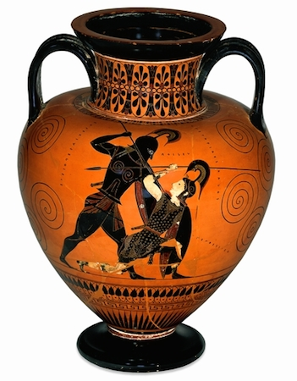  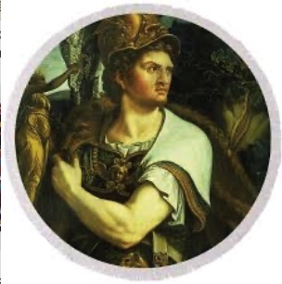  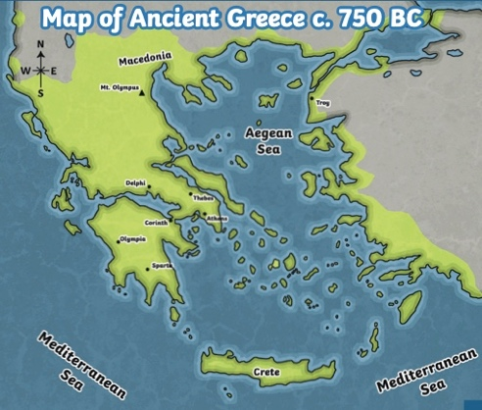  Map of Ancient Greece Alexander the Great Greek Pottery |  | Key Questions  Can you names some city stated in Ancient Greece?  What was Alexander the Great’s biggest achievement during his rule?  What events were held at the ancient olympic games?  Can you name 6 Greek Gods?

