Merlin Class | Amazing America |  |  | Spring Term 1
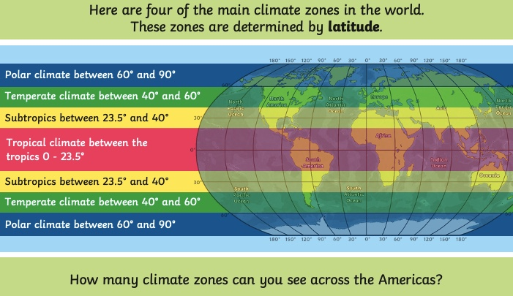  This term our topic focus is Geography, focusing on the ‘Amazing Americas’. As well as identifying many countries from North and South America, we will conduct an in depth study into a third world country of the children’s choice, comparing it with life in the UK. We will particularly be looking at the human and physical differences between the two.  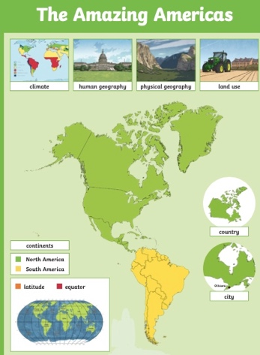  Death Valley in North America, straddles California and Nevada. It is known to be the lowests, hottest and driest national park making it famous for its extreme temperatures.  The Peak District in the UK covers 550 square miles across five counties; Derbyshire, Cheshire, Staffordshire, Yorkshire and Greater Manchester. Often referred to as Dark Peak for its gritstone edges and White peak for its limestone dales it contains a wide variety of landscapes. |  | Human Geography | The social science studying how people, societies, cultures, economies, and political systems interact with and shape the Earth's surface
 |  | Physical Geography | The study of Earth's natural features, processes, and systems, focusing on landscapes, climate, ecosystems
 |  | Equator | An imaginary line around the middle of the Earth at 0° latitude, dividing it into the Northern and Southern Hemispheres
 |  | Hemisphere | A hemisphere means half of a sphere or globe, most commonly used to describe Earth divided into halves (Northern/Southern by the equator
 |  | Continent | A continent is one of Earth's major, large continuous landmasses, generally defined by convention rather than strict rules
Questions
What is a continent?
What countries are in North/South America?
What physical features can be used to describe an area?
What human features can be used to describe an area?

