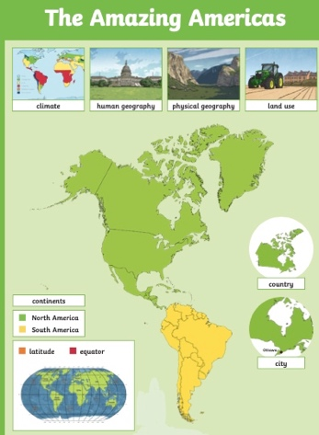
PSHCE
Our ‘Dreams and Goals’ unit will help us to reflect on how we fulfil our life goals. In Year 4 children will learn what it can look like to resilient and have self-belief and good motivation.
Year 5 will look deeper into dreams by think about what they’d like to be when they grow up and how they can achieve this through motivation and communication.
Merlin Class Topic Web
English
This term, children will be looking at Kensuke’s Kingdom. We will look closely at the narrative before using it to support us in writing our own. Children will use the text to learn to write setting and character descriptions, using skills such as adverbials to link paragraphs, varying sentence length and using noun phrases to add detail. Children will then look deeper at the story, using it to support writing a diary entry from the perspective of Michael, the lost boy.

Throughout both learning journeys, children will continue to develop their spelling, punctuation and grammar skills, as they develop maturity in their writing. Guided reading sessions will happen daily in small adult led groups.

Maths
Year 4 will be further developing their knowledge of multiplication and division using 2 and 3 digit numbers in written methods. They will spend time learning about length and perimeter as well as fractions and decimals.

Year 5 children will be learning about written methods of multiplication and division using 3 and 4 digit numbers. After this they will start to learn about decimals and percentages as well as perimeter, area and statistics.

Design and Technology
Children will take part in the Cookathon this term where they will develop and prepare a Caribbean dish. Children will investigate the impact of food source on the environment, understand and apply the principles of a healthy and varied diet as well as producing a step by step plan. They will use a range of tools and equipment competently when cooking.

Science
This term our science topic will be changes of materials. Children will learn about solids, liquids and gasses. They will conduct experiments to investigate separating mixture through filtering sieving and evaporating.
Children will also practice science skills such as planning experiments, recording and taking measurements accurately as well as recording and presenting data. They will development methods of presenting data and draw conclusions from it.

PE
All children will develop their gymnastics skills this term. Children will learn asymmetrical balances and travel as well as completing routines and sequences with varying heights and speeds. Year 4 children will also be taught volleyball, learning how to catch, send and receive the ball. This will develop into working cooperatively with a partner, developing skills to win games. Year 5 children will continue with their swimming practice and learn water safety.

Geography
We will visit North America looking at its environmental regions, countries and cities. Children will look at and describe geographical similarities and differences through the study of human and physical geography making comparisons with the UK.

Computing
This term children will become game creators. Children will explore and evaluate features of successful video games before planning, designing and using game sprites. They will then add features, check playability and evaluate games created by peers.
French
Children in Year 4 will learn how to say the date, recite numbers up to 31 and learn new vocabulary and phrases needed for class equipment.
In year 5 children will learn how to describe themselves and as imaginary Vikings as well as being able to describe what the weather is like and give a predicted forecast.
Music
Children will explore Sing Up. Identifying similarities and differences between pieces of music, listening and responding to music as well as matching vocal and instrument sounds.

