Puma The Rolling Stones Autumn Term 2
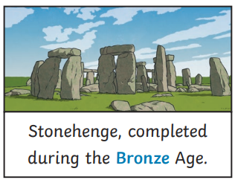
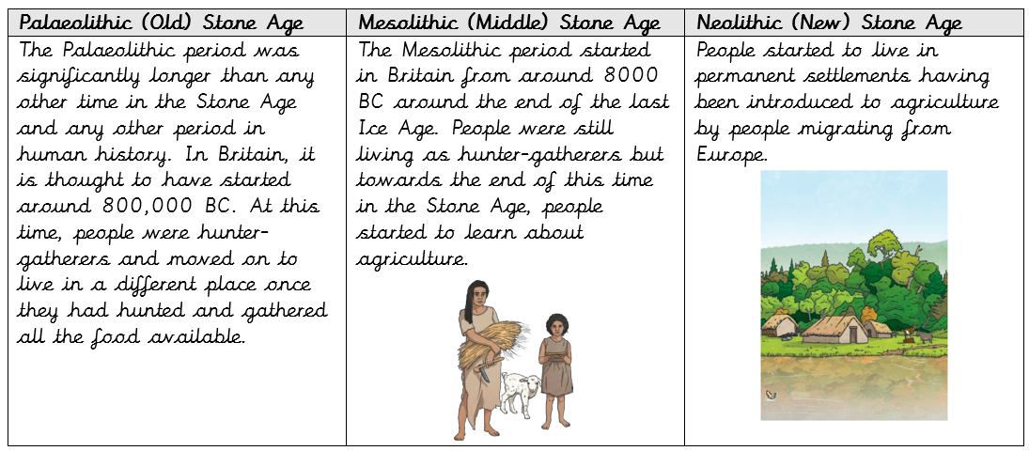
Key Facts
Bronze and iron enabled people to make more advanced tools and use improved materials.
The Stone, Bronze and Iron ages were named after materials that were used by people during that period.
In prehistoric times there were no written records to tell us what life was like, so we rely on artefacts that have survived to tell us how people lived.

Key Vocabulary
prehistoric | From a time in the past before there were written records.
hunter-gatherer | A person who moves from place to place in search of food. Surviving by hunting, fishing and collecting berries, fruits and seeds
agriculture | Growing crops and keeping animals for food and materials.
monument | A building or structure which is important for learning about the past.
tribe | A community of people, ruled by a leader, with shared traditions and culture.
settlement | A place where people live together in a community.
technology | Using knowledge to invent new devices or tools.
bronze | A metal alloy made from copper and tin.
iron | A metal that is stronger and harder than bronze.
celt | People living in Europe during the Iron Age.
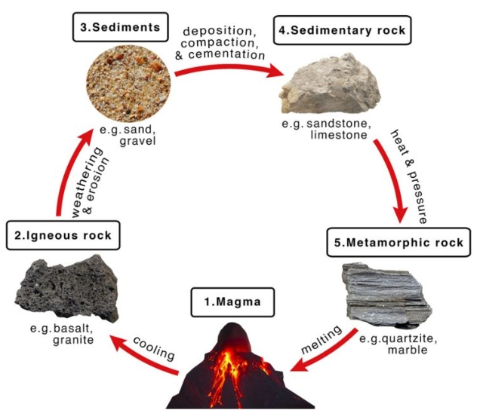
Key Questions
What did Stone Age people have to do?
How did life change when bronze was discovered, and later iron?
How did the different time periods get their names?
How do we find out about prehistoric times in Britain?

