Year: 6 Crime and Punishment Summer 1
Key Vocabulary:  CE: Common Era (what was known as AD)  BCE: Before Common Era (what was known as BC)  Punishment: The infliction of a penalty for an offence.  Law: A set of rules set by the government which may be enforced if someone does not follow them.  Torture: The action of inflicting severe pain on someone as a punishment or as a way to force another person to do something they do not wish to do.  Guillotine: A machine with a heavy blade designed to behead.  Gallows: A structure (usually made from wood) used for the hanging of criminals.  Pillory: A wooden framework with holes for head and hands used as a punishment for crimes.  Stocks: A wooden framework with holes for feet used as a punishment.  Branding: The action of branding with a red-hot iron as a punishment.  Mutilation: The action of removing body parts. | Important People:  King Henry VIII  Mary I  Elizabeth I  Queen Victoria  Sir Robert Peel | 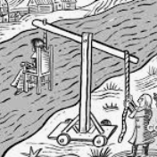  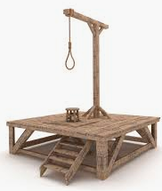  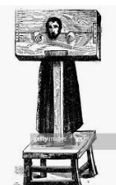  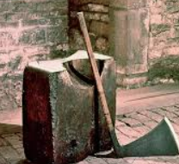  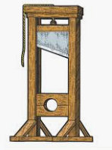
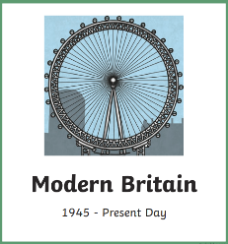
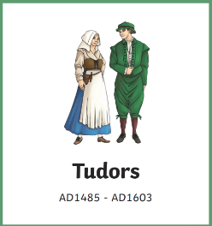
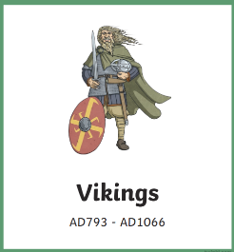
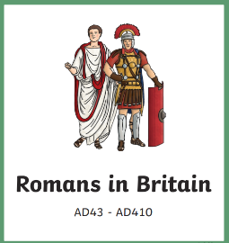
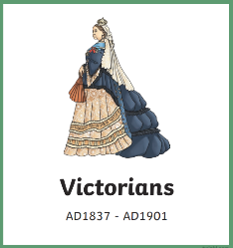
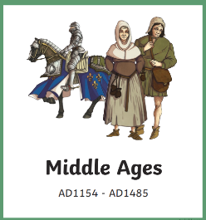
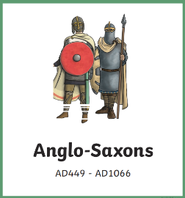
 | Key Questions:  Can you identify the similarities and differences of punishment in Britain from Medieval Britain to Modern Day? |  | Key Facts:  - The worst crime you could commit, in Medieval Britain, was high treason against the king.  - Sir Robert Peel introduced the police force in Victorian Britain.  - There was no police force before this period.  - During Tudor Britain, the heads of beheaded victims were placed on spikes outside the Tower of London.

