Year: 6 SOUTH AMERICA Spring 1
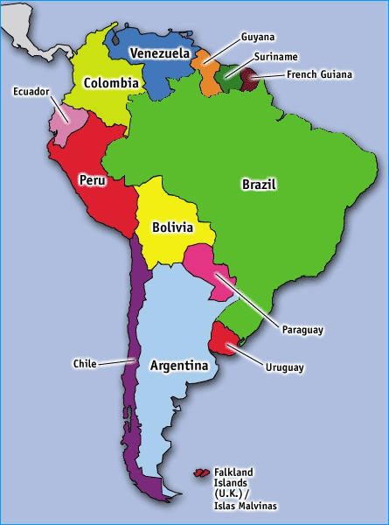  Map of South America: | Key Vocabulary:  Continent: A continuous expanse of land.  Country: Is land that is controlled by a single government.  Equator: An imaginary line around the middle of Earth, that is exactly halfway between the North and South Poles  Tropic of Capricorn/ Cancer: They are also imaginary lines that run above the equator (Cancer) and below the equator (Capricorn).  Time Zones: Is an area on Earth that has a specific time that all citizens can set their clocks to.  Mountain: A mountain is a landform that rises high above the surrounding terrain.  Fold mountain: Are formed when two tectonic plates move together.  Desert: A large region of land that gets very little rain each year.  River: A flowing, moving stream of water.
Flags of South America:
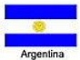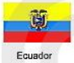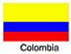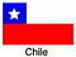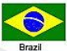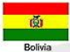
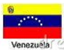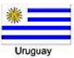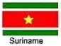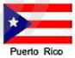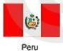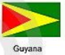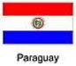
 | Key Questions:  What are the comparisons and differences between South America and the U.K?  What are the key human geographical characteristics?  What are the key physical geographical characteristics? | Key Facts:  - The longest mountain range in the world is in South America (the Andes).  - Its largest country is Brazil and its smallest country is Suriname.  - It has the second longest river in the world (the Amazon).  - There are many popular tourist attractions in South America, including Macchu Picchu.  - The Atacama Desert is the driest place in South America.  - South America is home to the largest Rainforest in the world (the Amazon).

