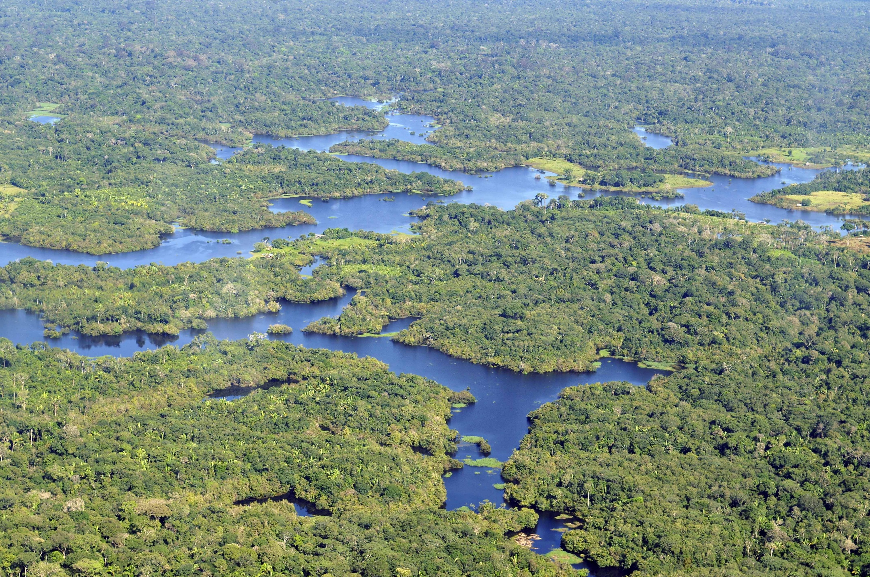
Science: This term, Chinook Class will focus on Living Things and Their Habitats. We will learn to classify living organisms into broad groups based on shared characteristics, including microorganisms, plants, and animals. Additionally, we will explore the significant contributions of Carl Linnaeus to the classification system and understand why his work remains important today.
Music: This half term, we will continue our brass instrument lessons, giving the children the chance to develop their teamwork skills as they learn, practice, and perform a piece of music together as a class. Additionally, we will be rehearsing the songs and accompanying actions in preparation for our exciting Young Voices trip later this term.
English: This term, we will explore Way Home by Libby Hathorne, a powerful and thought-provoking picture book that tells the story of a homeless boy navigating life in New York City. Through this text, the children will learn to analyze how language and illustrations work together to create specific effects on the reader. Our writing activities will focus on crafting vivid setting descriptions, composing poetry, and strengthening grammar and punctuation skills through targeted revision and practice.
Spectacular South America

Chinook Class

Spring 1
French:
This term Y5 will be learning:

How to describe themselves, using adjectives and grammar in character and physical descriptions (as a character in the Viking period)
How to describe the weather and present a weather forecast.

Y6 will be learning:

How to talk about the subjects they like and dislike at school, as well as the time they study various subjects.
How to discuss what activities they may do at the weekend, and their opinions about them.

Computing: During our weekly sessions, we will revisit the crucial topic of online safety, ensuring children understand how to navigate the digital world responsibly. Alongside this, we will explore how to create, operate, and effectively use spreadsheets to organize and analyze data.

PE: Year 5 will build teamwork and confidence through weekly swimming lessons, while Year 6 will refine their badminton skills.
Both year groups will prepare for the Indoor Athletics Tournament by honing their athletic abilities and teamwork.

Geography: In this unit the children will learn about the countries, culture and geography of South America. They will learn about the climate, the geographical features, the industries and the people of South America through a range of fun activities, giving them an insight into how life in South America is different to life here in the UK.

D&T: This term we will be cooking up a storm evaluating existing South American ingredients and dishes, creating a dish that meets our specification. All ready for the Cook-athon this term!
PSHCE: This term, we'll focus on setting goals, staying motivated, and working together. The children will learn to set personal goals, keep going when things get tough, and help others reach their goals. They'll also think about global issues that matter to them and how they can make a difference.

Maths: This term, Year 6 will complete their Algebra topic, while Year 5 wraps up an additional unit on fractions. Both year groups will then dive into decimals, covering place value, rounding, addition, subtraction, and multiplying/dividing by 10, 100, and 1,000, as well as applying these skills in real-world contexts. Alongside this, we will focus on sharpening arithmetic skills and boosting times tables fluency using Times Table Rockstars.

