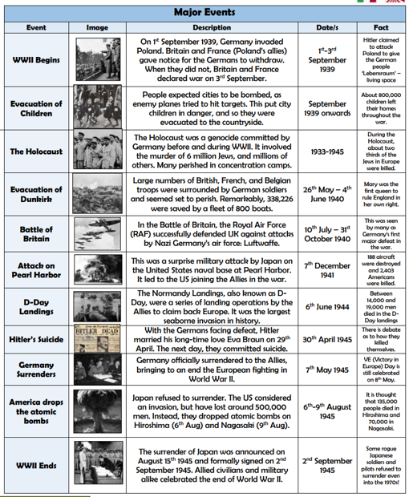
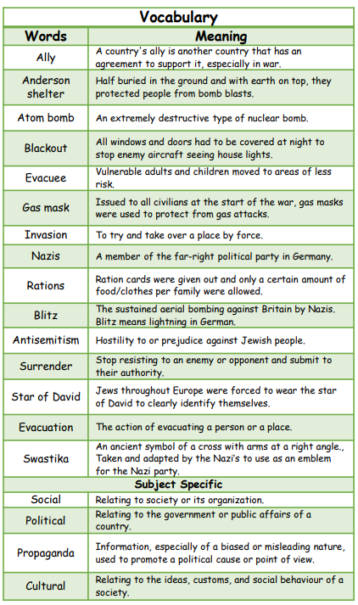
Why did WW2 start?
What was the Blitz?
In what ways did people keep themselves safe against bombing?
What was an evacuee?
What was lifelike for a Jewish child during WW2?
The Battle of Britain is considered as a turning point during WW2. Why is this?
What key event led to the US joining the Allies in the war?
How did people celebrate the end of WW2?

Key Questions
Key Facts
Vocabulary

