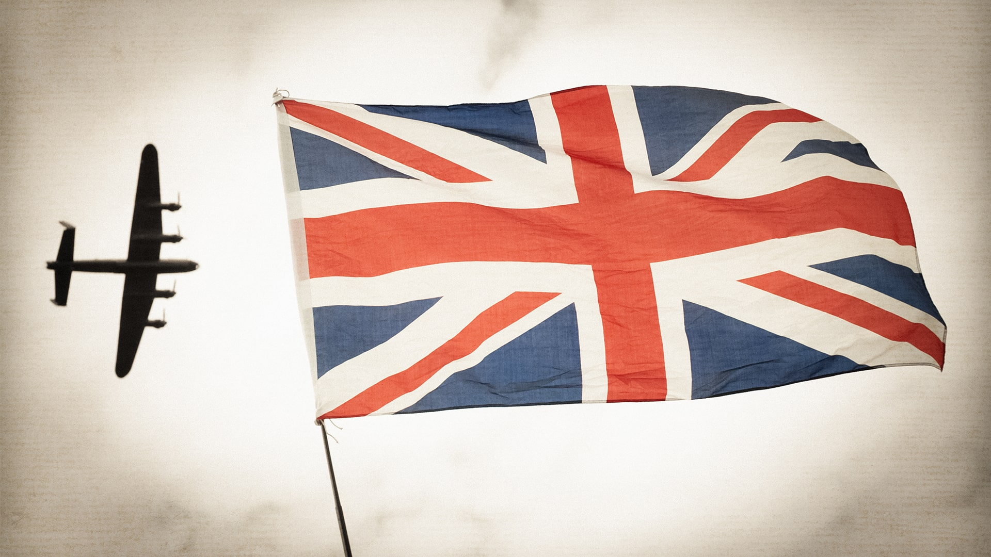
History: We will be using this opportunity to find out about the events that led up to and including the Battle of Britain. We will be looking at the significant events and people of the second world war. Our learning outcome will be celebrated during our WW2 Assembly.

PSHCE: This term we will be exploring the theme of ‘Being Me in My World’. Within our sessions we will follow the ‘Jigsaw Charter’ by showing consideration to others.

PE:
Year 5: This half term, Year 5 are going to be swimming every Wednesday gradually developing their skills in coordination, breathing and an understanding of water safety. Children will also work on all the strokes. We will also be working on our Gymnastic skills making fabulous routines and working collaboratively with our peers.
Year 6: We will also be doing Gymnastics (see above) as well as Tag Rugby. During our Tag Rugby sessions we will work on our footwork, evading and tagging opponents thinking about how we are going to avoid being tagged.

Music: This half term we will be taking part in brass instrument lessons. This will give the children the opportunity to work as a team to learn, practice and perform a piece of music as a class.
Computing: Our first computing topic will be coding, within this, children will be building on prior knowledge to solve problems using debugging and exploring creating their own adventure games.

D&T: This term we will be using the ‘Make Do and Mend’ campaign during WW2 to inspire us to design and make clothing culminating in a spectacular fashion show. The children will learn a range of different stitches and how to evaluate our final product against our design specifications.

Maths: The half term starts with number and place value, including a look at comparing and ordering numbers to 10,000,000, negative numbers and rounding numbers. After this we will move onto looking at all four calculation strategies and cover multiples, factors, prime numbers, cube and square numbers and the correct order of operations.

French: Chinook class will be learning names of countries and languages involved in WW2. They will also learn to describe differences between city and country life during the war for an evacuee.

Science: Our autumn term science focuses on Light. We will be exploring light sources, how light travels, reflective light and shadows. The children will be building on their Year 3 learning, exploring problem solving and working scientifically. This unit will be practical and exciting and will help to develop their critical thinking, collaboration and independence skills.

English: Our text this half term is ‘Once’ by Morris Gleitzman. ‘Once’ provides an introduction to the Holocaust and its impact on a young Jewish boy called Felix. We follow him on many an adventure, through narrative and diary writing. Our learning journey culminates in the writing of the first chapter for the sequel - ‘Then’.

Britain at War
Autumn 1
Chinook Class

