Squirrels Topsy Turvy Tales Spring 2
Our topic this term is all about alternative stories which show us how to be brave, how to help others and how to save the natural environment.
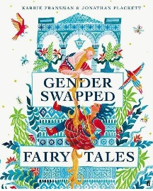  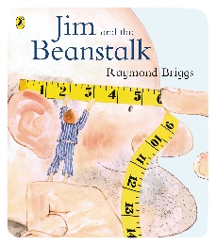  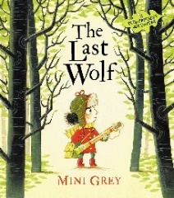  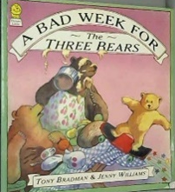  Key Texts:  Gender Swapped Fairy Tales by Karrie Fransman and Johathan Plackett  How would our fairy tales be different if the genders were reversed?  I wonder what happened after Jack climbed back down the beanstalk?  Jim and the Beanstalk by Raymond Briggs  The Last Wolf by Mini Grey  How can Little Red Riding Hood save the wolf and his home in the woods?  What happened before the 3 bears went on their walk?  A Bad Week for the Three Bears by Tony Bradman |  |  |  | Key Questions:  What are traditional tales?  What can we learn from the stories we read?  Where does the food we eat come from?  What food is eaten on a picnic?  Why are trees important?  What can we do to look after nature around us?
Helping the Environment:  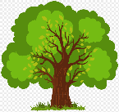  Plant Trees: We can plant trees and other plants to help animals find a new home and give us clean air to breath.  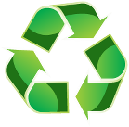  Recycle: We can make sure we put our rubbish in correct bin then some of our rubbish can be truned inot new things. This is called recyling. | Parts of a Story |  | What Does a Plant Need to Grow?  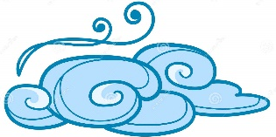  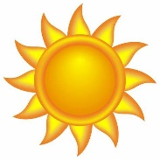  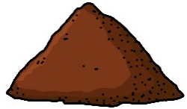  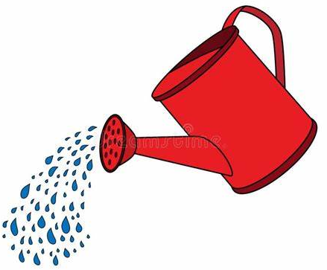  Sun  Soil  Water  Air
  Characters  The people or animals in the story. | Settings  Where the story takes place.
  Problems  The thing that goes wrong. | Solutions  How the problem is fixed.
Significant People  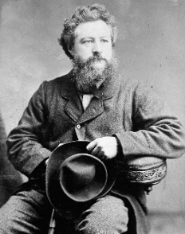  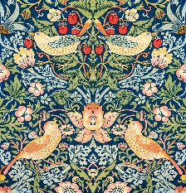  In the book The Last Wolf, we learn about the importance of the natural environment around us. William Morris was a painter who designed different prints for fabrics. He liked looking at the environment around him and used what he saw, like flowers and birds, in his designs. His images were used on things like chairs, carpets, and wallpaper. |  | Key Vocabulary:  Author: A person who write stories.  Prequel: A new story that takes place before the original story.  Sequel: A new story that takes places after the original story.  Tale: Another word for story.  Moral: An important thing we learn from a story.  Crown: A special type of hat worn by a King or Queen.  Natural Environment: Everything around us that is part of nature such as plants and animals.

