Squirrel Class Super World, Super Me Autumn 1
Key Questions:  1. Why am I important and what makes me special?  2. How can I describe my personality?  3. What are some things I can do and some things I am still working on?  4. Who is important to me?  5. What is the place like where I live and go to school?  6. Who helps to look after me and keep me safe?  7. Can anyone be a superhero?  8. If I had superpowers, what would they be? | Key Facts:  1. Reception class is for the youngest children in our school.  2. At school, we learn lots of things like Maths and Phonics.  3. Our school is on RAF Benson, this is where most of us live.  4. RAF Benson has people from the army, RAF and the navy.  5. An address tells somebody where you live, it usually has a house number and a street name.  6. There are many people whose job it is to look after us and keep us safe. |  |  | 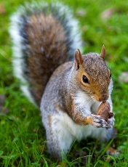  Forest School: Autumn  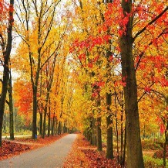  Autumn is a season, it comes after summer and before winter. In autumn, the leaves on some of the trees change colour and fall to the ground. Some animals, like squirrels, store food for the winter and some grow thick coats.
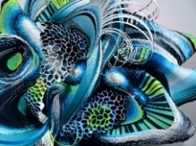  Super Artists: Crystal Wagnar  Crystal Wagnar is an amazing artist who is alive today. She uses paper to create sculptures. She folds, bends, cuts and joins the paper in lots of different ways.    Roy Lichtenstein  Roy Lichtenstein was a famous artist who painted bright, bold paintings of comic strip cartoons and everyday objects. The type of art he made is called Pop Art. |  | 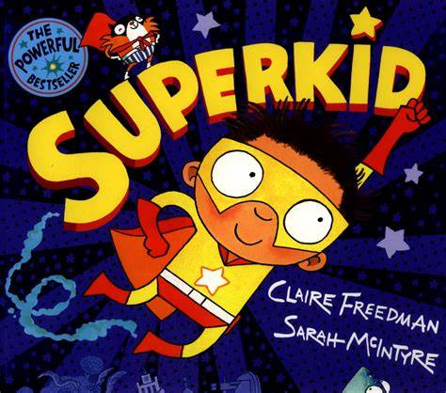  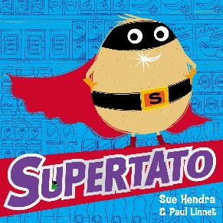  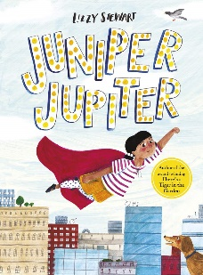  Key Texts  Supertato by Sue Hendra and Paul Linnet  Juniper Jupiter by Lizzy Stewart  Superkid by Claire Freedman and Sarah McIntyre
Key Vocabulary  Appearance: How someone looks, this could be their hair colour, eye colour, what they are wearing or something else about them that another person can see.  Emergency Services: The police, fire brigades or ambulance workers who help us when someone is hurt or in danger.  History: Something that has already happened.  Home: A place where someone lives.  Family: The people who care for us, some might live in our home and some might live in a different place.  Personality: How someone behaves, it could be that someone is funny, kind or helpful.  RAF Benson: The place in which our school is located.  Sculpture: A type of art that is 3D, it has height width and length.  Special: Someone or something that is different. Everyone is special in some way. |  |  | Significant People: Normal people can be heroes too.    A doctor helps people when they get ill or injured. You might also go to a hospital. If it’s an emergency special doctors called paramedics might take you in an ambulance.  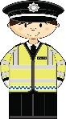  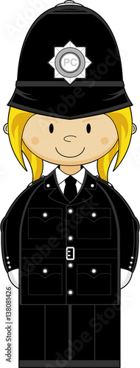  A police officer helps to keep everyone safe. They are a good person to look for if you get lost as they can help you. They sometimes have police dogs or horses to help them.  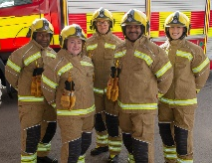  A firefighter stops dangerous fires and helps when people are trapped. They wear special helmets to protect their heads and masks to help them breath They drive in a fire engine.

