Squirrels Fabulous Festivals Autumn 2
Key Vocabulary:  Festival - A day or period of celebration, typically for religious reasons.  Christian – A person who follows the teachings of Jesus Christ, their special book is called the Bible.  Christmas – A Christian festival remembering the birth of Jesus.  Church- A special place for Christians where they go to pray and worship. Hanukkah – A special festival in Judaism, it means The Festival of Lights.  Hinduism – A religion followed by Hindus, they believe in one god but he can have many forms and names.  Judaism – A religion followed by Jewish people, they believe there is one god and their special book is called the Torah.  Mandir – A special place for Hindus, where they go to pray and worship.  Nativity – The story of the birth of Jesus.  Synagogue - A special place for people who are Jewish, where they go to pray and worship. | Key Questions:  - Why do we have two minutes’ silence on Remembrance Day?  - What happens on Bonfire night?  - Why is Diwali important to Hindus?  - What is Hanukah and how is it celebrated?  - Why do we have Christmas and who celebrates it?  - What traditions do other communities follow at Christmas?  - Which festivals do you celebrate?  - What do you do to celebrate special occasions? |  | Christmas  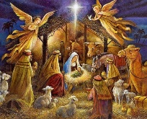  Christmas is a festival celebrated by Christians. The nativity tells the story of Jesus’s birth. To Christians it is a very important with lots of people like shepherds, angels and kings. There are also many traditions around Christmas such as Christmas trees, decorations, and Santa Claus. Before Christmas we have advent and there are other special events like Christingle before Christmas day. |  | Remembrance Day  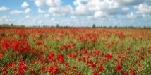  On Remembrance Day we think about all of the soldiers who have fought in wars to help to keep us safe. The poppy is worn because it was a flower that grew on the battlefields after the war. At 11 am on 11th November we stand in silence for 2 minutes to remember the soldiers who have died.
 | Bonfire Night and Fireworks Safety  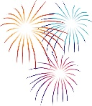  We celebrate Bonfire Night on 5th November. On Bonfire Night, people light bonfires and watch fireworks. It is very important that we stay safe on Bonfire Night. We must never go near a lit firework and must always stand where adults tell us to. If we hold sparklers, we should wear a glove and always put the sparkler in cold water when it is finished. | Diwali  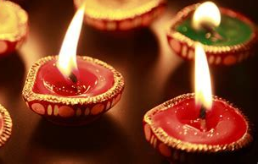  Diwali is the festival of light and is a time for new beginnings.  Hindus celebrate Diwali by:  - Wearing new clothes  - Cleaning their houses  - Lighting Diya lamps  -Making Rangoli patterns on their doorsteps. |  | Hanukkah  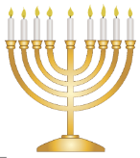  Hanukkah is a special day for people who are Jewish. Jewish people believe that a long time ago, there was a special candle. The candle was only meant to last for 1 day however it burnt for 8 whole days. To celebrate Jewish people light a candle each night for 8 days. The also play special games and decorate their homes.
 | Kings Day Portugal  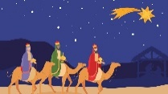  Kings Day is celebrated in Spain on 6th January. It celebrates the Three Wise Men being the first to deliver Christmas presents. On the night of 5th January, children leave their shoes by the door filled with straw and carrots for the horses of the kings. At night, the kings leave sweets and cakes in the shoes for the children. People in Portugal celebrate by cooking special food and singing. |  | 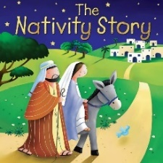  Key texts:  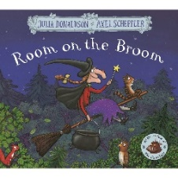  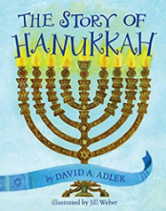  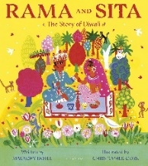  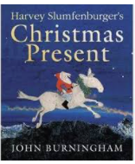  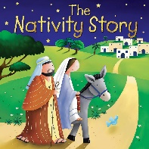  Halloween  Diwali  Hanukkah  Christmas and the Nativity

