Squirrel Class A Day at the Beach Summer 2
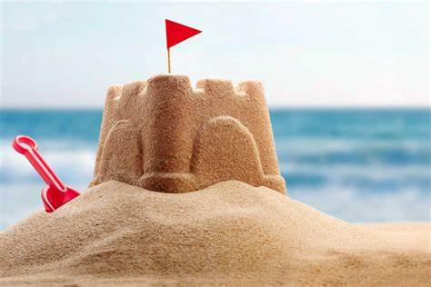  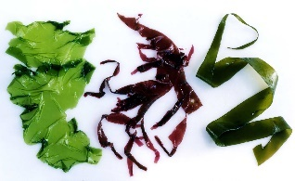  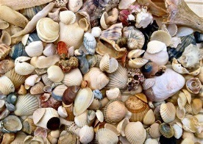  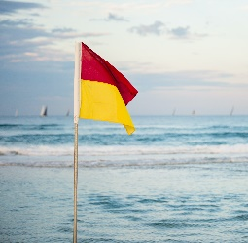  Things We Might See At The Beach  Sandcastles  Shells  Safety Flags  Seaweed |  |  | Key Questions:  What lives in the sea?  Which artists were inspired by the seaside?  What can I do at the beach?  How can I look after sea creatures?  How do I stay safe near the sea?  What was going to the seaside like in the past?  How has the seaside changed over time?
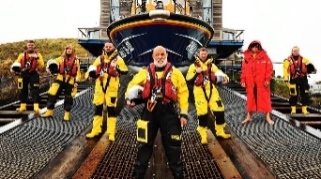  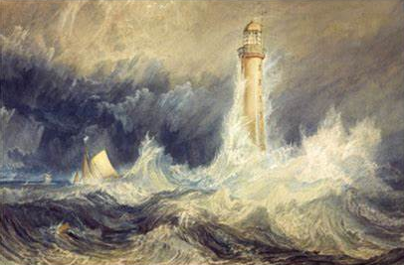  Significant People  The RNLI are a charity that save people who get into danger at sea. They have lots of special equipment like boats and life jackets to help them. Most of the people who work for the RNLI are volunteers, this means they don’t get paid.  J.M.W.Turner was an artist who lived over 200 years ago. He painted Bell Rock Lighthouse which shows a storm around a lighthouse. |  | 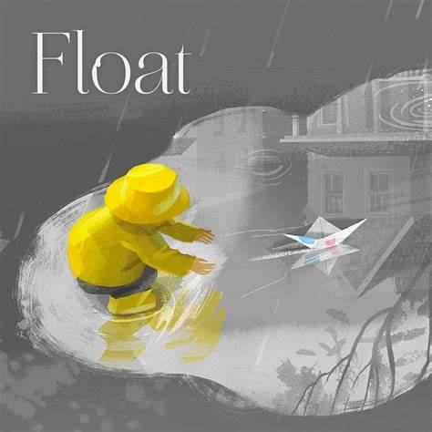  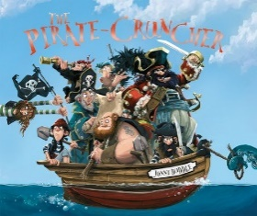  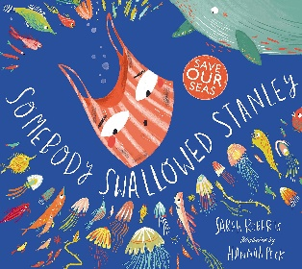  Key Texts:  Float by  Daniel Miyares  Somebody Swallowed Stanley by Sarah Roberts  The Pirate Cruncher by Jonny Duddle
At the Seaside in the Past  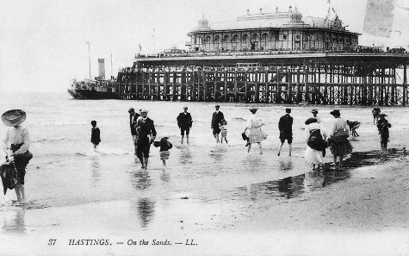  A day at the seaside has changed a lot. In the past, people wore different clothes for going to the beach and did different things when they were there. They even had bathing machines for getting changed in. They did do some of the things that we still do, like eating ice-cream. | Key Vocabulary:  Beach – A sandy or rocky part of land next to water.  Coastguard – People who will help if someone has an emergency in the sea.  Coral Reef – The home of many different types of plants and animals.  Past - Something which has already happened.  Sea - A large area of salt water nearly surrounded by land. It is smaller than an ocean.  Tourist – Someone that travels to another place on holiday.  Water Pollution – When bad things that can hurt humans or animals get into the water. |  |  | Problems for the Sea  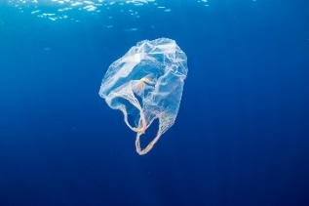  Sometimes people are not careful about where they leave their rubbish. Instead of putting it in a bin or recycling it, they leave it on the beach. The rubbish then goes into the sea and hurts the plants and animals living there. Animals can get stuck in the rubbish or think it’s food.

