Squirrel Class All Aboard for an Amazing Adventure Spring 1
Key Vocabulary:  Distance: How far one thing is from another.  Explorer: Someone who goes on adventures to new places.  Journey: Going from one place to another.  Past: Things that have already happened.  Penny-Farthing: A bicycle from the past, it had a large front wheel and a small back wheel.  Steam Train: A train powered by hot air called steam.  Sled: Something used to travel on ice and snow, it has long planks instead of wheels and is sometimes pulled by dogs.  Transport: Something that helps people get from one place to another. |  | Key questions:  How many different types of transport are there?  What transport have we used?  How was transport different in the past?  Which artists paint transport?  What is the best type of transport for different journeys?  How is transport different around the world?  How is Chinese New Year celebrated? |  | UtW: Transport Round the World  In other places around the world, people have to use different transport to travel. In Venice the city is full of water, so people travel in special boats called Gondolas. In some places there isn’t enough land for a plane to land on, so they have special sea planes that can land on water. Sometimes cars cannot drive where it is snowy and icy, so they use sleds pulled by dogs instead.
EAD: Transport Through Art    Vincent Van Gogh was an artist. He liked to paint lots of things. Some of his paintings looked like real things. In some of his paintings, he made things look different from how they were in real life. | 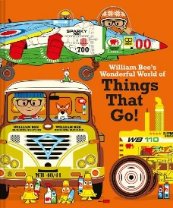  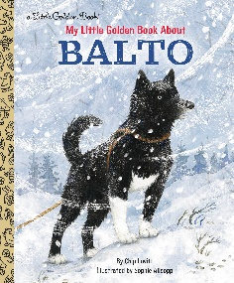  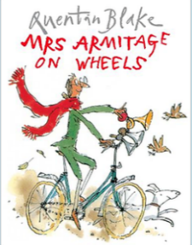  Key Texts  William Bee’s Wonderful World of Things That Go! By William Bee  Balto by Chip Lovitt  Can you see  Can you find the name Balto somewhere else on here?  Mrs Armitage on Wheels by Quentin Blake |  |  |  | 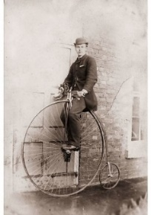  UtW: Transport in the Past  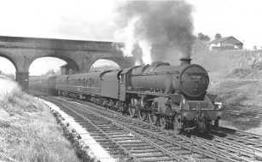  People in the past used different transport from the ones we use today. They sometimes rode in carriages pulled by horses or on trains powered by steam. Even their bicycles looked different!
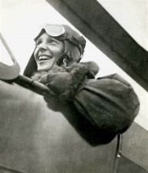  UtW: Significant People and Animals  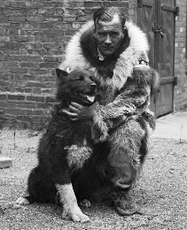  Amelia Earheart was a famous pilot. She was the first woman to fly an aeroplane, by herself, across the Atlantic Ocean. It was a very long way to fly. When people told her that girls couldn’t fly, she flew anyway.  Balto was an Alaskan Huskey and sled dog. When children in the village where he lived got sick, he helped lead a team of sled dogs to the nearest train station to collect the medicine they needed. It was a very long journey which took a number of days. People said that Balto couldn’t do it because he was a young dog, but he did. |  |  | Chinese New Year    This year, Chinese New Year is on Wednesday 29th January. This year it is the year of the Snake. Chinese New Year is a big celebration with fireworks, dragon dancing and lots of different foods. There is also a special story for Chinese New Year called ‘The Zodiac Story’.

