Apache Year 4 | Enigmatic Egyptians |  | Spring 2
Our science focus for this term is ‘Sound’
What is volume?  The volume is how quiet or loud a sound is. The more something vibrates, the louder the sound. If a drum is hit hard, it will vibrate more and create a loud sound. If the drum is hit gently, it will vibrate less and the sound will be quiet.  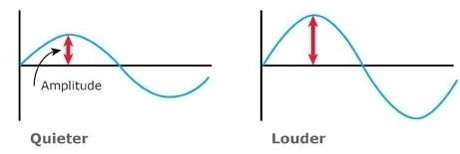  What is pitch?  Pitch is how high or low a sound is. All sounds are made by vibrations. The slower the vibrations, the lower the sound and the quicker the vibrations, the higher the sound. Pitch can be measured by recording frequency waves. High frequency waves represent a high number of vibrations and a high pitch. Low frequency waves represent a low number of sound vibrations and a low pitch.  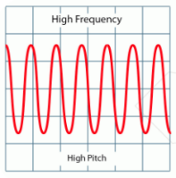  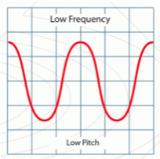 |  | How are sounds made?  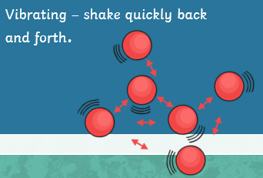  Sound is a type of energy which is measured in decibels and all sound are made when something vibrates. Vibrations from the source of the sound make the air around the object vibrate and create sound waves. Sound waves can travel through water and metal as well as air. The size of the vibrations is called the amplitude. Louder sounds have a larger amplitude, quiet sounds have a smaller amplitude.  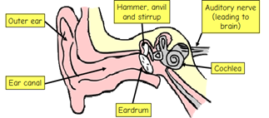  Pitch (high or low) depends on the frequency of the vibrations.  Echoes occur when sound waves bounce off surfaces and return.  Different materials affect how sound travels, and some materials conduct sound better than others.
Vocabulary  Auditory nerve - carries sound message from the cochlea to the brain  Eardrum – thin sheet in ear that vibrates when hit by sound wave  Decibels - unit of measure of sound  Outer ear – the visible part of an ear  Hammer, anvil & stirrup – small bones found within the ear  Cochlea – part of the ear that changes sound waves into nerve messages  Volume - The loudness or softness of a sound. It is determined by the amplitude (strength) of the vibrations. |  | Key Questions  How are sounds made?  What is a sound vibration?  What’s inside your ear?  Does the size of the pinna affect the volume of the sound?  What is pitch?  What is volume?

