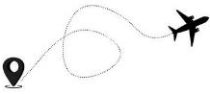
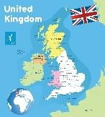
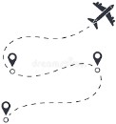
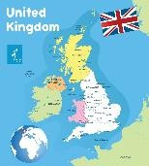
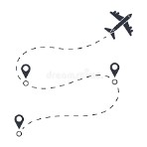
v
Apache Class Summer Term 2 Contrasting with Cyprus
Music
In music this half term, we will be looking at a fast rock style with a driving rhythm. We will learn to sing and play in a class band.
Computing
In computing this half term, we will be learning about hardware investigations, where we will be understanding the different parts that make up a desktop computer. Following this, we will be making music on Purple Mash.
RE
In RE this half term, we will be learning about Buddhism. We will be exploring what the best ways for a Buddhist to lead a good life are. Additionally, we will be looking at examples of the Eightfold Path that a Buddhist might put into action in their lives.
PE
In PE this half term, we will be learning athletics and tag rugby. In athletics, we will start by practising the events in readiness for Sports Day. Throughout the term, we will then be focusing on running, jumping and throwing activities. We will also be using a variety of equipment to measure, time and compare different styles of runs, jumps and throws.
In tag rugby, we will be learning basic tag rugby skills, implementing rules and developing tactics in competitive situations. We will also be increasing speed and building endurance during gameplay.
D&T
In D&T this half term our learning will be closely linked with our science topic of Electricity. Our focus will be on making circuits with bulbs and switches. The children will make a wire loop game consisting of circuits with bulbs and switches. We will start with the specification then investigate other loop games. We will develop our electrical skills then design our game.

English
In English this half term, we are going to be learning about poetry
then writing a non chronological report. Whilst looking at poetry we
will be using the book The Lost Words, to support our writing. We
will be comparing and contrasting different poems and ultimately
writing our own poem using the identified features.
Additionally, we will have specific grammar learning including prefixes and suffixes, specifcally ‘’-ous’ and ‘-ly’.
Our second piece of writing will be linked to our geography lessons where we will be comparing the UK with Cyprus.

Maths
We will start this half term by continuing our learning on shape. We will be looking at polygons and symmetry within shapes.
Following this, we will then move onto our final topics of the year which will include statistics, position, and direction. Within statistics, we will be exploring charts and graphs, with a view to interpreting them and drawing line graphs.
In addition to these topics, there will be regular times tables practise in readiness for the multiplication check in early June. Throughout their learning, the class will also have the opportunity to apply their knowledge in problem solving.
PSHCE
Our final topic in PSHE which we will be exploring this half term is ‘Changing Me’. In this topic, we will be exploring how everyone is unique and understanding how being unique is special. Following this, we will be learning about the internal and external parts of male and female bodies that are necessary for making a baby. Finally, we will be learning about puberty, menstruation, and the consequent changes to the body.

Science
In science we will be learning about electricity. We will identify everyday appliances that run on electricity. We will also look at what electricity is and find out where it comes from. After that, we will look at what basic parts are needed in a simple series electrical circuit and identify common conductors and insulators. The children will investigate how to make an electrical circuit with bulbs and switches.
Geography
In geography this half term, we will start by using maps, atlases, globes and digital/computer mapping to locate countries. We will then focus our learning specifically on the UK and identify the countries that form it as well as identifying counties and big cities. We will then be learning about human and physical geographical similarities and differences between Oxfordshire, a county in the United Kingdom, compared with a region in Cyprus. We will be using Ordnance Survey Maps as part of this to learn more about the eight points of a compass. We will be taking the opportunity to carry out some fieldwork to observe and record the human and physical features in the local area.

