Year 4 | Contrasting with Cyprus |  | Summer Term 2
Key Vocabulary:  British Isles: Includes England, Wales, Scotland, Northern Ireland and the Republic of Ireland.  Country: An area of land that is controlled by its own government.  Equator: An imaginary line around the Earth halfway between the poles, dividing the surface into the Northern and Southern hemispheres.  Europe: A geographical land area, Europe is a continent located entirely in the Northern Hemisphere.  Landscape: Everything you can see when you look across an area of land, including hills, rivers, buildings, trees, and plants.  Physical geography: Natural features of land such as mountains.  Population: All the people who live in a country or area.  Rural: Places that are far away from large towns or cities, the countryside.  United Kingdom: Includes Scotland, England, Wales and Northern Ireland. |  | European Capital Cities  Major UK Cities  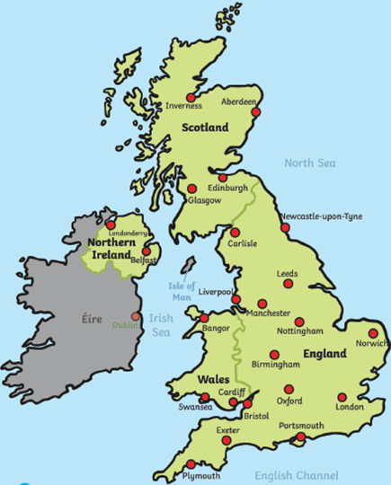 |  | 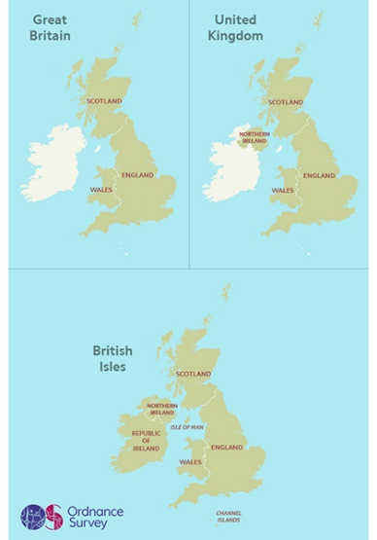  UK, British Isles and Great Britain  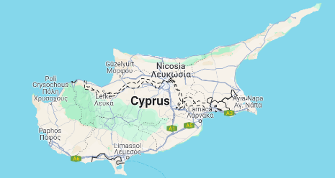  Cyprus
  Country | Capital
  United Kingdom | London
  France | Paris
  Spain | Madrid
  Cyprus | Nicosia
  Italy | Rome
  Norway | Oslo
  Belgium | Brussels
  Germany | Berlin
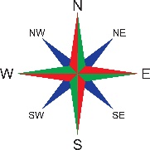
Key Questions:
What are the names of the seven continents?
What are the names of the oceans?
How do the UK, Great Britain and the British Isles differ?
Why are people attracted to living in cities compared to rural areas?
How would you travel from London to Glasgow?
What do the points of a compass mean?
Where is the UK and Cyprus located on a map?
What are the human and physical similarities and differences between the two countries?
Key Facts:
A country’s name is often written in capital letters on a map. Capital cities usually have a different symbol to other cities on a map.
Europe and the European Union are not the same. Europe is a geographical continent and the European union is a group of some of the countries in Europe.

