Apache Year 4 | Fabulous Food |  | Spring 1
Our science focus for this term is ‘Animals including Humans’.
Teeth  Depending on what type of food an animal eats, we can class them into one of three groups:  • Herbivores eat plants.  • Omnivores eat both plants and other animals.  • Carnivores eat other animals.  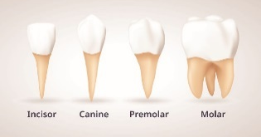  Different animals are adapted to eat different food types which means that their teeth can look very different. Humans have 4 different types of teeth.  These are:  Incisors Teeth with a flat edge, at the front of the mouth, used to bite food.  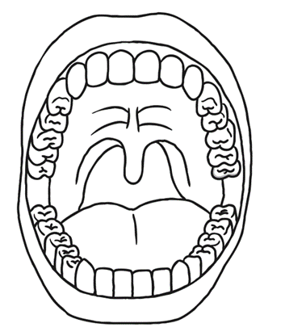  Canines These are pointy teeth used to tear food.  Premolars These are located between the molar and canines and are used to chew food.  Molars These are the teeth at the back of the mouth which are used to chew and grind food. |  | 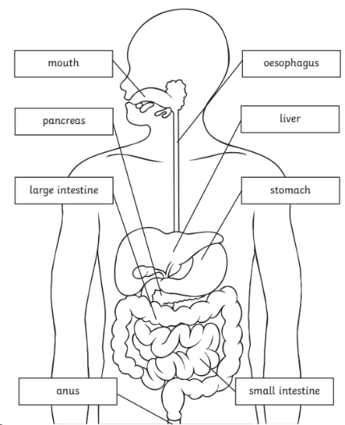  The Digestive System  Mouth  When food goes in the mouth, it is broken down by your teeth, mixed with saliva and is then swallowed.  Oesophagus  When we swallow our food, it moves down the oesophagus into your stomach.  Stomach  When the food reaches your stomach, it is churned with stomach acid to kill any germs which may be on it.  Small intestine  When the food leaves the stomach, it enters the small intestine. This is where food is broken down and nutrients are absorbed into the blood.  Large intestine  In the large intestine, more water is reabsorbed into the blood. Any food that cannot be absorbed is then stored in your anus until you go to the toilet.
Key Vocabulary  Digestive system – This is where your body breaks down food and absorbs nutrients.  Food chain – A series of plants and animals, each of which is eaten as food by the one above in the series.  Producers – The name given to a living thing that produces its own food, rather than consuming another living thing.  Predators – An animal that hunts other animals.  Prey – An animal that is hunted or killed by another animal for food. |  | Key Questions  Why do we eat?  What happens to food when we eat?  What is the function of different teeth?  What is the digestive system?  What is the function of the digestive system?  What is a food chain?

