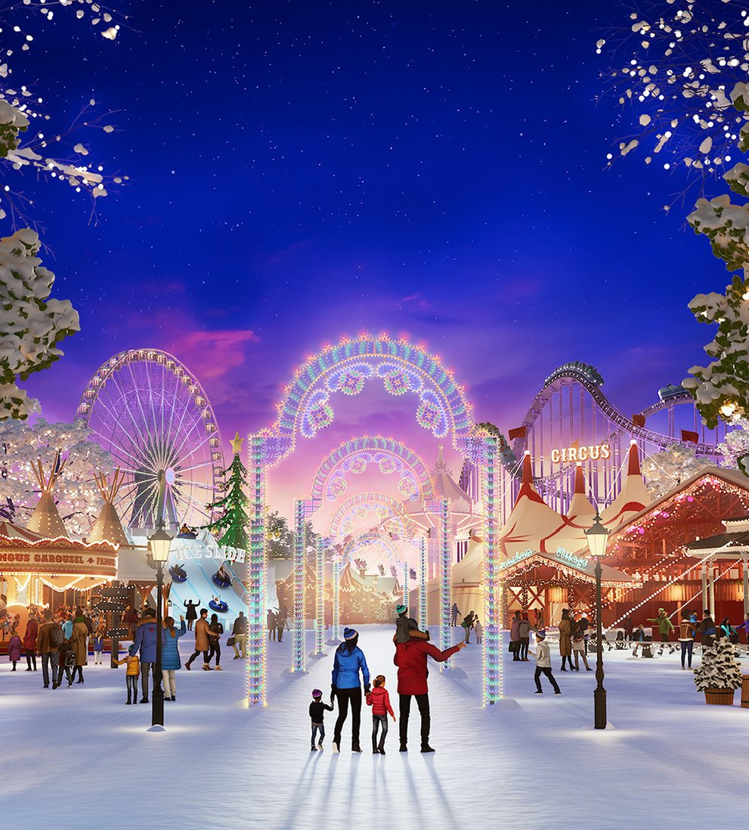
English:
This term our class text will be ‘The Lion, The Witch and The Wardrobe’ by C.S. Lewis. We will be learning how to write an informal letter and narrative on the children’s visit to Narnia through the magical wardrobe. Our grammar focus will be expanded nouns and sentences of three.
Additionally, we will be continuing to practice spellings and handwriting. Part of our spelling focus will be on the prefixes ‘in‘, ‘il-‘, ‘-im’ and ‘ir-‘ and suffixes ‘’-ing’, ‘-er’, -‘en’ and ‘-ed’. We will also continue to practice our Year 4 statutory words.
PHSE:
Our topic in our Jigsaw PSHCE sessions this half term will be the topic of ‘Celebrating Difference’.
Through this topic, we will explore how to best accept and include others with kindness. We will be discussing judging by appearance, first impressions and what influences our thinking on what is normal. We will also consider the way in which our differences make us who we are and will share what makes us all special.

PHSE:
Our focus is going to be ‘Changing Me’’. We will start by discussing how self-image links to self-esteem. We will then be discussing how the female and male bodies change during puberty. We will also identify the stages of sexual reproduction and pregnancy. Finally, we will reflect on our feelings about becoming a teenager in the future and moving to Year Six.
Philosophy:
Our focus is going to be on ‘Healthy Me’. This will include discussing the risks of smoking and alcohol to people’s health. We will also learn about what to do in emergency situations. Afterwards, we will discuss the link between social media and body image, as well as eating healthily.
Geography:
We will be focusing on physical geography this half term and will start by learning about the course of a river and explore some of the world’s largest rivers.
We will then identify and explore mountain ranges across the world. We will be using atlases and online maps to locate where these are in the world. This will lead us onto understanding the water cycle which will link to our learning in science about evaporation and condensation. .

Winter Wonderland

Autumn 2 – Year 5

Autumn term one – Year Five

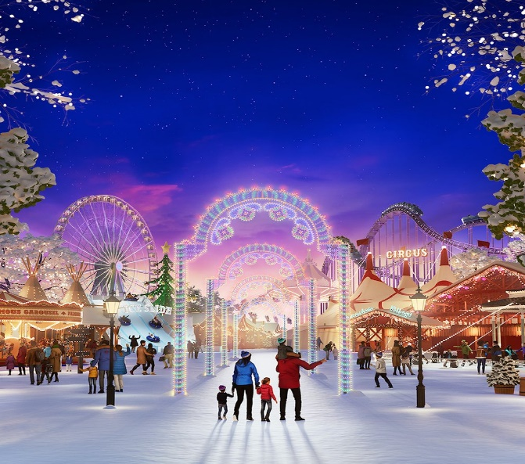
This
ART:.
In art, this half term, we are going to be focusing on printing, specifically looking at texture and shape. We will be exploring and evaluating the work of Rachel Moore. We will use her printing as inspiration for our own artwork linking our work with the initial setting of Narnia from the Lion, the Witch and the Wardrobe.

Apache – Autumn 2
Science:
Our science topic this term will be ‘States of Matter’. Linking to our English text, ‘The Lion, The Witch and the Wardrobe’, as Lucy discovers in Narnia, we will be exploring ice and water. We will be learning how to identify solids, liquids and gases, and will explore how particles differ for each state of matter. We will also investigate the way in which temperature affects a material’s state and will consider both reversible and irreversible changes. Throughout our lessons, the children will continue to develop their skills in observation and recording through practical investigations.
RE:
This half term, we will start by focusing on beliefs and practices in Buddhism, specifically learning about the life of Buddha and exploring how he tried to be happy and stay happy. We will be asking is it possible for everyone to be happy?
We will then focus on Christianity, specifically exploring what the most significant part of the Nativity story
Physical Education:
For our outdoor PE this half term, we will be learning hockey. For our indoor PE, will be playing badminton. In both of these sports, we will be learning and practising the key skills.
Music:
In music this half term, we will be exploring the doot doot song with classroom percussion. We will doodle with our voices over the chords in the song and ensure we sing rhythms lightly and accurately.

Computing:
In computing this half term, we will be learning about writing for different audiences.
Maths:
Our topic this term will be ‘Multiplication and Division’. Within this, we will be aiming to embed fluency skills with different times tables, whilst also practicing strategies to be able to use multiplication facts to find unknown facts.
Additionally, we will continue learning times tables both in class and on Times Tables Rockstars

