Apache Year 4 | Winter Wonderland |  |  |  | Autumn 2
States of matter: Materials can be one of three states: solids, liquids or gases. Some materials can change from one state to another and back again.
Solid  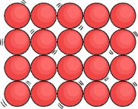  Particles in a solid are close together and cannot move. They can only vibrate.  Solid materials keep their shape unless a force is applied to them. They can be hard or soft.  Solids take up the same amount of space no matter what has happened to them | Liquid  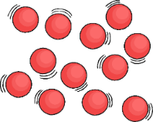  Particles in a liquid are close together but can move around each other easily.  Liquids take the shape of their container. They can change shape but do not change the amount of space they take up. They can flow or be poured. |  | Gas  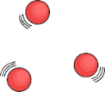  Particles in a gas are spread out and can move around very quickly in all directions.  Gases can spread out to completely fill the container or room they are in. They do not have any fixed shape, but they do have a mass. | 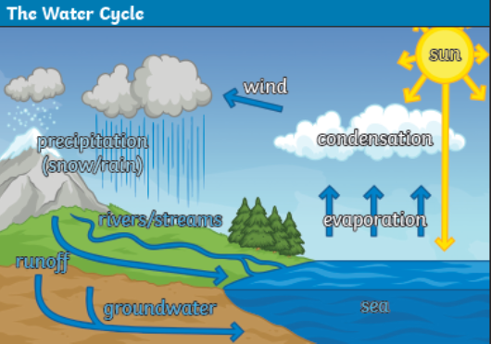  Key facts  Changes of state occur as a result of heating or cooling.  The temperatures at which changes happen at are called the boiling, melting or freezing point.  Melting Solid → liquid  Freezing Liquid → solid  Changes of state occur as as result of heating or cooling.  Heating or cooling changes the particles within a material.  Condensation and evaporation occur within the water cycle.  Evaporation Liquid → gas  Condensation Gas → liquid
Additional Key Vocabulary  Water Vapour – This is water that takes the form of a gas. When water is boiled, it evaporates into water vapour.  The Water Cycle – The process of water moving around between the air and land.  Precipitation - Liquid or solid particles that fall from a cloud as rain, sleet, hail or snow. |  | Key questions  How does heating and cooling change a state of matter?  Can changes of state be reversed?  What are melting, boiling and freezing points?  How does precipitation fall from the sky?  Why is temperature relevant to the water cycle?

