Apache Year 4 | ASTOUNDING ANGLOS |  | Summer 1
Key History Vocabulary  Angles: Tribes from an area today known as modern day Denmark that settled in Britain from around AD 450. They were one of the tribes that became known as the first Anglo-Saxons.  Invaders: People who enter an area and take control of it by force.  Jutes: One of the Germanic tribes who settled in Great Britain after the departure of the Romans.  Picts: Tribes originally from Scotland who were often feared.  Scots: People from Ireland who, like the Picts, were fierce and powerful fighters.  Key History Facts:  There had been Angles, Saxons and Jutes living in Britain during Roman rule. Some had been soldiers or auxiliaries and some were traders and merchants.  Most Angles, Saxons and Jutes settled in the east of England.  Gradually, some people become more powerful, and kings emerged.  Eventually, there were seven different kingdoms in England.  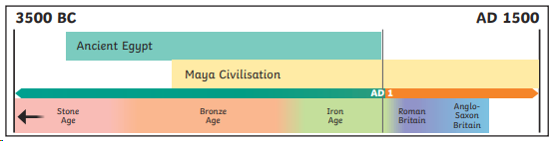  Timeline  Key History Questions  Who were the Anglo-Saxons?  When did they settle in Britain?  What were Anglo-Saxon homes like? |  | Key Science vocabulary  Practical work - doing a hands-on activity or experiment to test something and see what happens.  Fair testing - A fair test means you only change one thing (the thing you're testing), and you keep everything else the same. This way, your results will be correct and fair.  Data - the information you collect during your experiment. It can be numbers, measurements, or things you notice.  Prediction - what you think will happen in your experiment, before you do it.  Findings - what you discovered or learned after doing the experiment. It’s what the results show.  Conclusion - a sentence or paragraph that explains what happened in your experiment and whether your prediction was right.  Evaluate - to think about how well your experiment went.  Key Questions  What are the steps involved in the scientific method?  What is a comparative fair test?  What is a scientific conclusion?  What is a hypothesis?  What do I need to include when conducting a practical experiment, recording findings in a table and drawing conclusions from data?  

