 | DIDCOT & WALLINGFORD NEIGHBOURHOOD POLICING TEAM  QUARTERLY UPDATE  JUN-AUG 2026
 | HELLO SUMMER! 🌻  Welcome to the Neighbourhood Team’s 4^{rth} quarterly newsletter  We are keen to share information with you all about current trends and challenges that are affecting our communities and invite feedback from parents about the issues that matter the most to you and your children, as well as offering advice on how to manage issues at present.
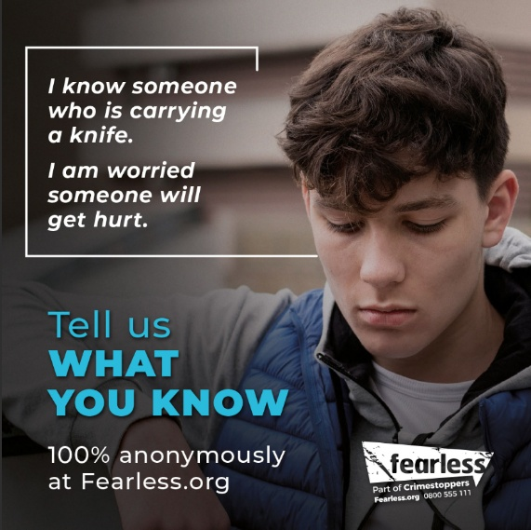 | 🔪 #KnivesRuinLives – THINK SMART, STAY SAFE  In the coming weeks, police across the country focus on educations and prevention of knife crime. You may see this referred to as Op Sceptre.  Unfortunately, knife crime in the UK is an ongoing issue, taking the lives of young people far too often. This HAS to stop, and this CAN be stopped with your support and taking that extra moment to think before you act.  📈 KNIFE CRIME STATISTICS:  - 806 people have been murdered with a knife or sharp object in the last 10 years.  - 14 children aged 16 or younger were murdered with a knife or sharp object in the last year.  - 49,151 police-recorded knife offences last year alone  - 18% of those offenders were aged 10-17 years old  ⚠️ THE REALITY:  - Carrying a knife is a serious offence  - It can lead to life-changing consequences  - It puts everyone at risk – including the person carrying it  💬 FOR STUDENTS:  - You don’t need a weapon to stay safe – walking away and speaking to someone is always the stronger choice.  - If anyone tells you to carry a knife “just in case,” that’s a warning sign – not advice.  - One moment, one decision, can change your future completely.  👉 Be the one who walks away — not the one who regrets it.  👨‍👩‍👧‍👦 FOR PARENTS/CARERS:  Conversations at home really do make a difference. You don’t need to have all the answers – just creating a safe space to talk openly is key.  Things to look out for may include:  - Sudden changes in behaviour or mood  - New friendship groups that raise concern  - Reluctance to talk about where they’ve been or who they’re with  Education/training is available through BenKinsella - https://benkinsella.org.uk/knife-crime-training-for-parents-and-carers/  ✅ What to do:  If you’re worried about yourself, a friend, or a child:  - Speak to school staff  - Contact local police (101)  - Report anonymously via Crimestoppers or fearless.org  💡 REMEMBER:  “Real strength is making safe choices.”  There is always a better option – and always someone ready to help.  This video shows the reality, told be Amani Simpson who ended up involved in knife crime. - https://www.youtube.com/watch?v=Jm6PwChWiJ8 (viewer discretion is advised due to the videos and pictures shown)
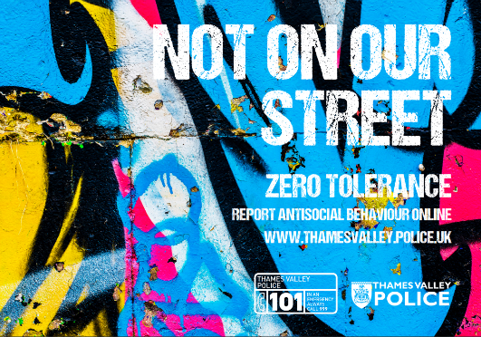 | ANTI-SOCIAL BEHAVIOUR – SUMMER FUN, NOT SUMMER TROUBLE!  Warm weather brings people together – parks, green spaces, town centres – and that’s something to enjoy.  But when behaviour crosses the line, it can quickly affect others in the community.  💬 FOR STUDENTS:  - Hanging out is fine – causing damage, shouting late at night, or intimidating others isn’t  - Respect shared spaces – they belong to everyone  - If your group is starting to go too far… be the one who says “let’s not”  👉 We have recently dealt with a lot of youths for anti-social behaviour incidents, resulting in youth justice outcomes. This can result in a criminal record. Don’t let a bit of fun turn into a big problem.  👨‍👩‍👧‍👦 FOR PARENTS/CARERS:  - Young people don’t always realise what counts as anti-social behaviour  - Simple conversations about respect and boundaries make a huge difference  - If concerns come up, early support is always better than escalation  ⚠️ THE REALITY:  Anti-social behaviour can lead to:  - Police involvement  - Fines or consequences  - Impact on future opportunities  ✅ QUICK TAKEAWAY:  Respect your space, respect your community.
 | OUT & ABOUT – ENJOY SUMMER, STAY STREETWISE  Longer evenings = more time with friends, which is great for confidence, independence, and fun ☀️  We just want to make sure everyone stays safe while enjoying it.  💬 FOR STUDENTS:  - Stick with people you trust – there’s safety in numbers  - Let someone know where you are and when you’ll be back  - Keep your phone charged (10% battery = 0% plan!)  - Trust your instincts – if something doesn’t feel right, it probably isn’t  👉 Being independent means making smart choices, not risky ones.  👨‍👩‍👧‍👦 FOR PARENTS/CARERS:  - Agree on check-in times or messages  - Know where your child plans to be  - Help them plan safe routes home  🌟 REMEMBER:  You can still have a great time and stay safe – the two go hand in hand.  ✅ QUICK TAKEAWAY:  Have fun. Plan ahead. Look out for each other.
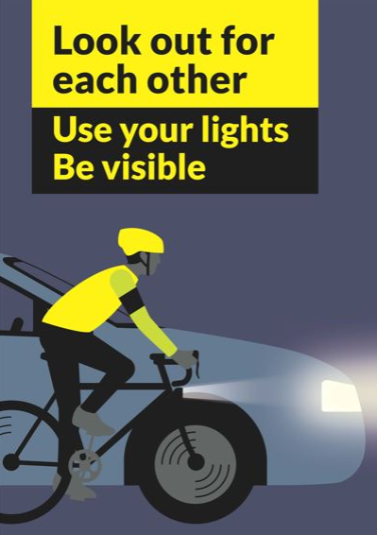  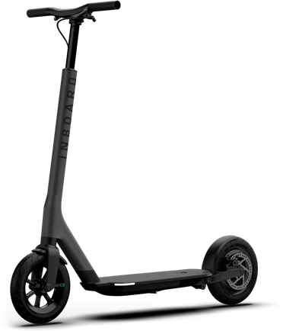 | BIKE & SCOOTER SAFETY – DON’T LET YOUR RIDE TAKE A SLIDE!  With the sunshine finally making an appearance (about time!), we’re seeing more bikes, scooters, and e-scooters out and about – which is great! 🚴‍♂️  But with more wheels on the move, it’s important to keep safety front and centre, and to remember what is legal and what is not!  💬 FOR STUDENTS:  - Helmets might not be the “coolest” look… but neither is a trip to A&E – safety beats style!  - Stay alert – headphones in = awareness down 🎧  - Watch out for roads, driveways, and other people – it’s not a racetrack!  - Make sure to adhere to road signs – we see too many people cycling the wrong day down one-way streets and going through red lights. This is a danger to you and other road users & pedestrians.  And a big one…  👉 Look after your ride – bikes and scooters are a top target for theft in summer.  👨‍👩‍👧‍👦 FOR PARENTS/CARERS:  - Check bikes are roadworthy (brakes, tyres, lights)  - Encourage helmets and visibility  - Remind young people to lock bikes securely, even for short stops  ⚠️ DID YOU KNOW?  Privately owned e-scooters are NOT legal to use in public spaces (roads, pavements, parks).  Using one will result in it being seized and destroyed and could lead to you getting fines and points on your driving license.  ✅ QUICK TAKEAWAY:  Be seen, be smart, and protect your ride!
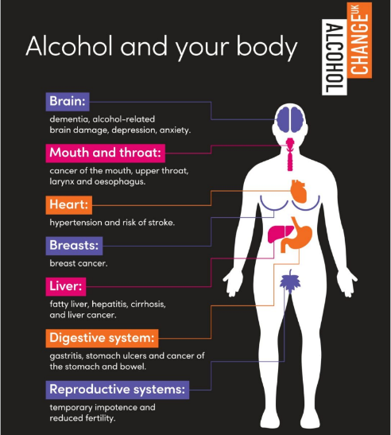 | UNDERAGE DRINKING – DON’T LET IT SPOIL YOUR SUMMER!  Warmer weather, time off school, and spending more time with friends can sometimes lead to situations where alcohol is involved. While it might be seen as “part of growing up,” underage drinking can quickly lead to risky situations, poor decisions, and unsafe situations.  💬 FOR STUDENTS:  - Alcohol lowers your awareness – meaning you’re more likely to take risks or end up in unsafe situations  - It has a negative impact on your health.  - It can lead to arguments, accidents, or putting yourself in danger without realising it  - If someone is pressuring you to drink, that’s not respect – that’s pressure  👉 You don’t need alcohol to have a good time – your best memories won’t come from bad decisions.  👨‍👩‍👧‍👦 FOR PARENTS/CARERS:  Summer is a key time to have open, honest conversations.  Young people are more likely to make safer decisions when they feel informed and supported.  Things to consider:  - Know where your child is and who they’re with  - Agree clear expectations around alcohol  - Encourage your child to call you if they feel unsafe – no questions asked in the moment  ⚠️ DID YOU KNOW?  - It is illegal for someone under 18 to buy alcohol  - Alcohol is often linked to anti-social behaviour, vulnerability, and exploitation  - Being under the influence makes young people more likely to become victims of crime  ✅ What to do:  If a situation feels unsafe:  - Stay with trusted friends  - Move to a safe place  - Contact a parent, carer, or trusted adult  💡 REMEMBER:  “Stay in control – don’t let alcohol make the decisions for you.”
 | EXAM SEASON – YOU’VE GOT THIS!  For many of our students, the next few weeks are all about exams – revising, preparing, and maybe feeling a few nerves along the way. That’s completely normal, and we want to take a moment to wish every single one of you the very best of luck!  💬 FOR STUDENTS:  - You’ve put in the hard work – now it’s time to show what you can do  - It’s okay to feel nervous – it means you care  - Take breaks, get rest, and don’t forget to eat (fuel matters more than flashcards!)  👉 Do your best – that’s all anyone can ask.  👨‍👩‍👧‍👦 FOR PARENTS/CARERS:  This can be a stressful time for young people, so your support really does make a difference.  You can help by:  - Keeping routines calm and consistent  - Encouraging rest and balance (not just revision!)  - Reminding them that results don’t define who they are  🌟 A FINAL MESSAGE:  Exams are important, but so is your wellbeing. Confidence grows from effort.  ✅ QUICK TAKEAWAY:  Stay positive, stay prepared – and remember, you’ve got this!  🎉 FROM EVERYONE AT DIDCOT & WALLINGFORD NEIGHBOURHOOD POLICING TEAM:  Good luck to all students sitting exams this term – we’re rooting for you!
   | Thank you for taking your time to read this newsletter!  Your feedback is really important to us and helps form our policing priorities.  Have Your Say! Meetings are a great forum to feedback your concerns, and also anything positive! You can find a list of upcoming meetings on our TVP Website:  Didcot  Wallingford, Berinsfield and Cholsey  If you haven’t done so already, you may like to sign up to Thames Valley Alert, so that you can receive free crime alerts and information about where you live. To do this you can either go to www.thamesvalleyalert.co.uk or use the following barcode:  

