Puma Northern Lights Spring Term 2
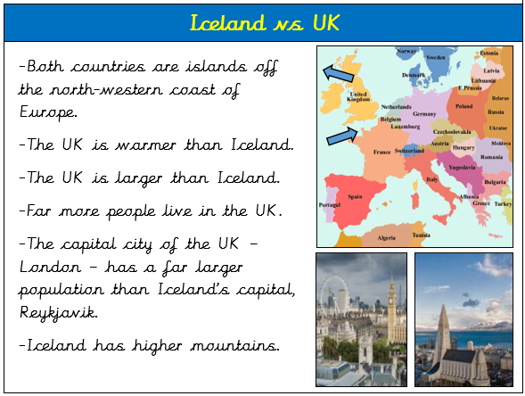
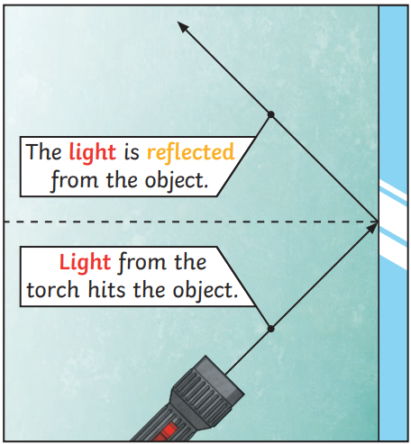
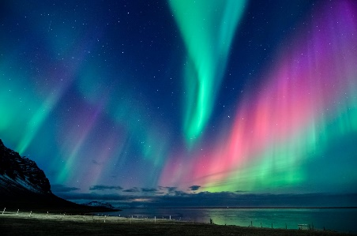
Remember these skills from last term?
Key Questions

What surfaces best reflect light?
What affects the size and shape of shadows?
What similarities are there between Iceland and the UK?
What is different in the physical geography of Iceland and the UK?
The Northern Lights in Iceland.

The Northern Lights are
shades of light seen in
the sky near the North
Pole.

The Northern Lights are
caused by tiny particles
from the sun hitting
gases in the atmosphere.

Key Facts
We need light to be able to see things.

Light travels in a straight line in a ray or beam.

Light reflects off an object into our eyes so we can see it.

Shadows are formed when an opaque object has blocked the light.
Key Vocabulary
UK | The United Kingdom of Great Britain and Northern Ireland.
Great Britain | England, Scotland and Wales.
Continent | Group of countries.
Europe | Continent containing the UK and Iceland.
county | A small area of the UK containing lots of towns and villages
physical geography | Natural features of geography. Eg. river, mountain,
human geography | Man-made features of geography Eg. churches, towns.
population | Number of people living in that area.
light | A form of energy that travels in a wave from a source.
light source | An object that makes its own light.
dark | The absence of light.
reflection | The process where light hits the surface of an object and bounces back into our eyes.
shadow | An area of darkness where light has been blocked.
opaque | Objects that do not let any light through.
translucent | Objects that let some light through and scatter the rest.
transparent | Objects that let light through easily.
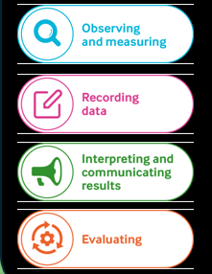
We will be revisiting all these as we learn more about light and its properties.


