
We are your School Nurses!


Southeast Locality

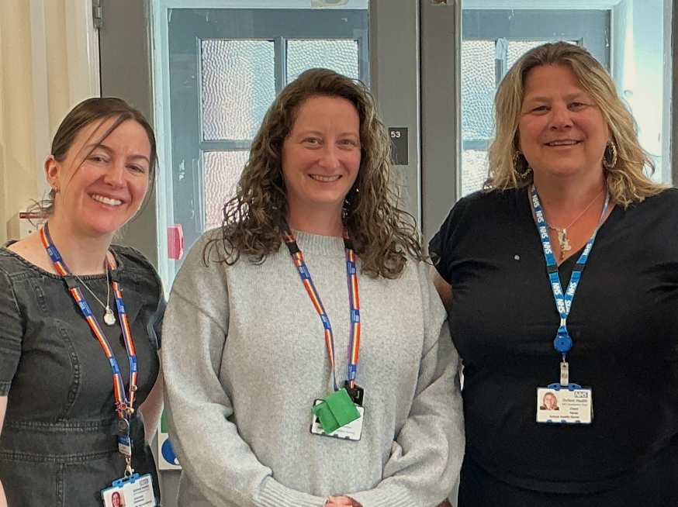
We are a team of qualified school health nurses and associates who support children in school with medical needs. We provide advice on health-related issues, offer health reviews, support for families with complex needs, and assist with health promotion activities.
Contacting us:
ChatHealth -ParentLine, is a texting service for parents and carers. You can text anytime of the day or night, and you will have a response from a member of the 0-19 CYP team the next working day, between 9am -5pm Monday to Friday (excluding Bank Holidays).
Parents /carers of children age 0-4 - 07312 263081
Parents /carers of children age 5-11– 07312 263227
ChatHealth age 11-19 07312263084
You can refer to us via the 0-19 CYP Single Point of Access Email: cyp0-19@oxfordhealth.nhs.uk 01865 903800

