Puma Force of Nature SUMMER Term 2
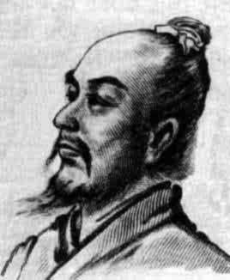
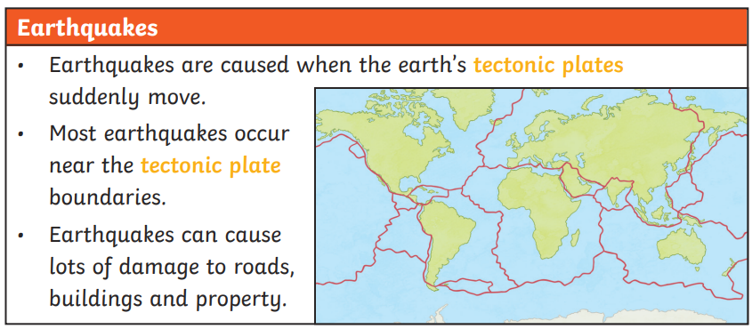
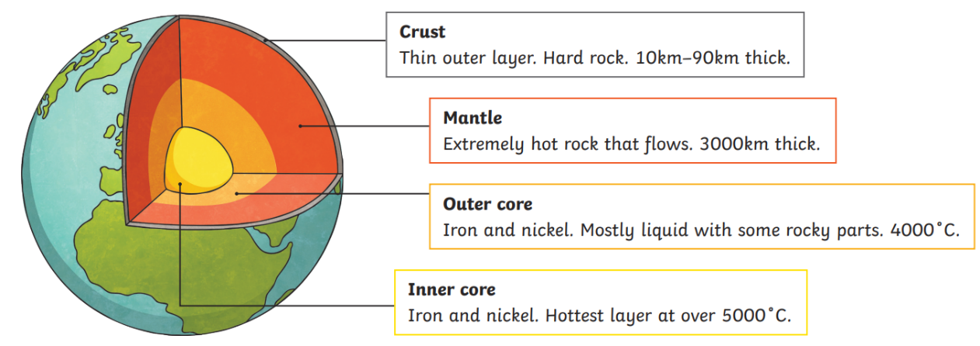
Chang Heng
Inventor of the 1st seismoscope
132 CE
Key Vocabulary
physical geography | geography created or caused naturally
erupt | To suddenly burst out causing lava to explode out of the earth’s surface.
magma | Extremely hot, liquid rock.
tectonic plates | large areas that make up Earth’s surface
forces | pushes or pulls
friction | a force that acts between surfaces or objects that are moving, or trying to move, across each other
magnet | an object which produces a magnetic force that pulls certain objects towards it
magnetic | objects which are attracted to a magnet
poles | north and south poles are found at different ends of a magnet
repel | pushes an object away
attract | pulls an object towards it
Key Facts: Forces and Magnets
Forces will change the motion of an object. They will either make it start to move, speed up, slow down or stop.
Different surfaces create different amounts of friction, this depends on the roughness of the surface and the object and the force between them.
A magnetic field is invisible.
In magnets, like poles repel and opposite poles attract.

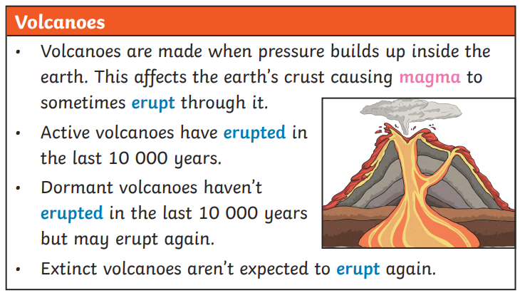
Key Questions
What materials are magnetic?
How are volcanoes formed?
Where in the world are there volcanoes?
What happens when a volcano erupts?
What causes an earthquake?

