History
In history this term we will be learning all about the ancient civilisations of the world. We will be looking at the writing, trade, architecture and technology of Ancient Greece, Ancient Egypt and the Shang Dynasty. Children will learn where and when these civilisations began and what impact they have had on how we live today. We will focus in on the Shang Dynasty, learning about its culture and major figures. We will be able to make links to life in the UK during the Bronze and Iron age and compare differences.
English
This term in English we will be looking at two beautiful stories: ‘Journey’ a beautiful picture book without words and ‘The Magic Paintbrush’, a Chinese fable. Children will read, discuss and use ideas from these books to inspire them to develop their narrative and playwriting writing skills. Throughout both writing projects, children will be given the opportunity to explore examples of both text types, identifying the different features they use and their purpose. Children will explore the vocabulary (or lack of) and practice using new higher-level language in their own sentences. They will have time to practice the grammatical skills required to produce a narrative and playscript, before planning, drafting editing and publishing their own versions.

Maths
We will start this term off by continuing to develop our multiplication and division skills. Children will use partitioning to help them solve calculations involving multiplying a 1-digit number with a 2-digit number. They will then use the division to complete the inverse, dividing 2-digit numbers by 1-digit. This will help the children identify links between multiplication and division and apply known times table facts to help them solve problems. Towards the end of this half term children will then move on to learning about length and perimeter, where they will be using millimetres (mm) and centimetres (cm) to measure and calculate the length of sides and perimeters of shapes.

Design &Technology
We are going to become chefs this term as we discover the tastes of Chinese cooking. We will be evaluating current recipes, using our science knowledge of a healthy diet to consider the nutritional value of different dishes. Children will have the chance to design their own meal, using traditional Chinese ingredients before developing their cooking skills by preparing a dish to enter into the school’s ‘Cookathon’ competition!
Dynasties
Puma Class
Spring Term 1
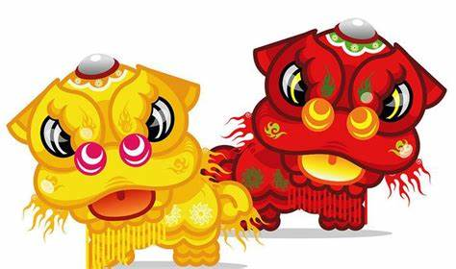

PSHE
‘Dreams and Goals’ is our new theme. We will explore obstacles and challenges and will consider how to develop resilience and perseverance.

Science
This term our focus is how to work scientifically. We will be developing our skills in asking scientific questions and predicting their answers. We will set up our own scientific enquiries and learn different ways of how to present the results (such as by using charts and graphs). We will also decide on the best ways to communicate what we have found out. This is an excellent time for working on our groupwork skills as we solve problems in groups of 4.

Computing
Continuing with our Purple Mash scheme of work, we will be learning how to use spreadsheets to support our science investigations. We will look at turning a table into a bar chart or line graph. Later in the term we will begin to learn skills to help us touch type.

Music
The focus this term is Latin Dance music. We will
compose a 4-beat rhythm, sing a call-and-response song and recognise a verse/chorus structure. We will play a one-note part contributing to the chords accompanying verses.

French
This term Madame Whitty will help us in learning the names of days of the week and months of the year.
We will also recognise, recall, remember and spell 10 familiar animals and create short phrases with the verb ‘I am’.
P.E.
In netball we will be learning how to pass the ball consistently with chest passes and shoulder passes. We will learn how to bounce the ball in order to pass and will begin to play elements of the game, considering teamwork and defensive strategies.

In badminton we will learn how to hit the shuttlecock with some control and speed. We will practise hitting to and from different areas of the court and begin to take part in a rally.

