Puma Dynasties Spring Term 1
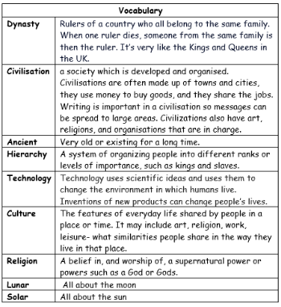
Key facts
- The Shang Dynasty was the first civilisation in China to develop a writing system using pictographs on bones, bamboo and silk.
- The Shang Dynasty ruled from 1600 to 1046 BC and was the first recorded Chinese dynasty with both written and archaeological evidence³⁴⁵.
- The Shang Dynasty made advances in maths, art, astronomy, bronze working, chariot, and weapons.
- The Shang Dynasty was based on agriculture, hunting and animals, and they built their buildings from mud.

Key questions
- What was the earliest civilization?
- How many ancient civilizations were there?
- What impact did the ancient civilizations have on our lives today?
- What was the wheel first used for?
- What is the difference between a primary and secondary source?
- What does CE and BCE stand for?
Find out who I am.
I am a warrior!

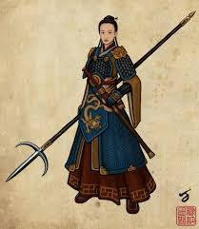
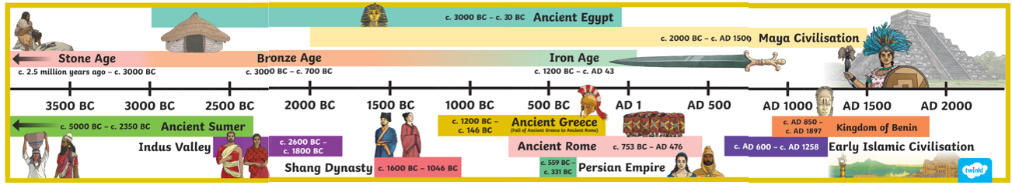
Ancient Civilisations Timeline

