History
History will form the basis for our topic this term. We will kick the term off with a stone-age day, where we will immerse ourselves in a exciting hands on experiences.
We will be learning all about life in prehistoric Britain through a study of the Stone Age and the changes that followed during the Bronze Age and Iron Age. We will explore how Stone Age people survived as hunter-gatherers, as well as discovering important Stone Age archaeological sites, such as Stonehenge. Throughout our topic, will consider the importance of historic artefacts and sites in giving us clues about the past before the time of written records.
English
Our class text this term is ‘The Wild Way Home’. A wonderful adventure story linked to our Stone Age topic. In English, we will be comparing this longer text to the shorter narrative 'Stone Age Boy'. Through both stories, we will be developing our vocabulary, grammar and punctuation skills as well as looking at the style and structure of writing to support us as we to create our own adventure stories.
We will also look at the book ‘How to Wash a Woolly Mammoth’ where we will explore the features of instructional writing. Children will use this text to help them develop their own set of funny instructions, combining all the elements they have learnt and practiced during the term.
Maths
We will start this term off by recapping the addition and subtraction skills we learnt last term, ensuring we have the column method to add and subtract embedded. Then we will move onto learning about multiplication and division. Children will use pictorial representations to create equal groups and will learn how to use arrays to multiply. Children will also use arrays to complete divisions through sharing. This terms multiple focus will be revising the 2, 5 and 10 times tables, before moving on to learn the 3, 4 and 8 times tables. This will involve using doubling and having, as well as learning to use the inverse to find division facts.

The Rolling Stones
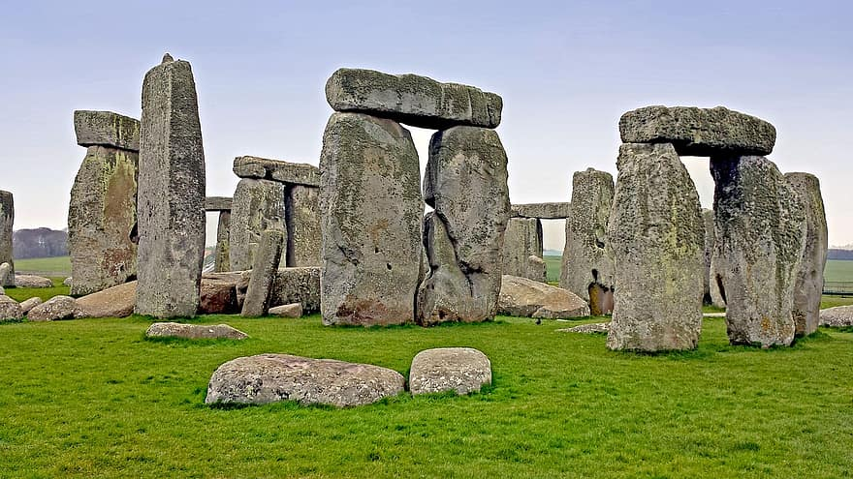
Puma Class
Autumn Term 2

Art
Rocks are the theme of our art this term, from making rock-based crafts , recreating prehistoric cave paintings, making iron age clay pots to learning about the artist Barbara Hepworth and her magnificent stone sculptures!
Our artworks will be a variety of 2d and 3d creations using a range of materials such as natural pigments and stones, and sculpting with soap and clay.

Computing
We move on to online safety and spreadsheets where we will be organising and collating information and presenting it for others to understand.

Look out for the online safety posters coming home!
PSHE
Continuing our Jigsaw scheme of work, this term we will work on the topic ‘Celebrating Difference’ and will consider how we all get along together.
Additional information
Library -please bring in library books on Mondays.
We need: We still need painting shirts and any old cereal boxes
Thank You.
P.E.
In P.E. this term please ensure a full P.E. kit is in school all week, including footwear; this will all be sent home on Fridays for washing.
Dance- Strictly Y3 Dancing! We will be putting together a sequence of moves and performing to other groups, thinking about character as well as props.
Football- We will be learning some basic ball control skills, leading up to attacking play.

Music
Using a Latin beat, we will compose a 4-beat rhythm pattern to play during instrumental sections.
Working in small groups, we will practise our call-and-response whilst learning a song.
We will also learn how to play a one-note part contributing to the chords accompanying the verses.

R.E.
We will be beginning our Y3 studies with some big questions. Starting with Islam, and asking ‘Does praying at regular intervals help Muslims in their everyday lives?’
We then move on to Christianity and ask, ‘Has Christmas lost its true meaning?’
Science
Science will focus on rocks, soil and fossils. We will be learning about igneous, metamorphic, and sedimentary rocks and finding out how these three types of natural rock are made. We will use their different properties to help us classify a selection of rock samples. We will consider why certain rocks are used for specific purposes, including man-made rocks, and will examine our local environment before moving on to discover how fossils are formed and examining the composition of different soils using our investigation skills.

