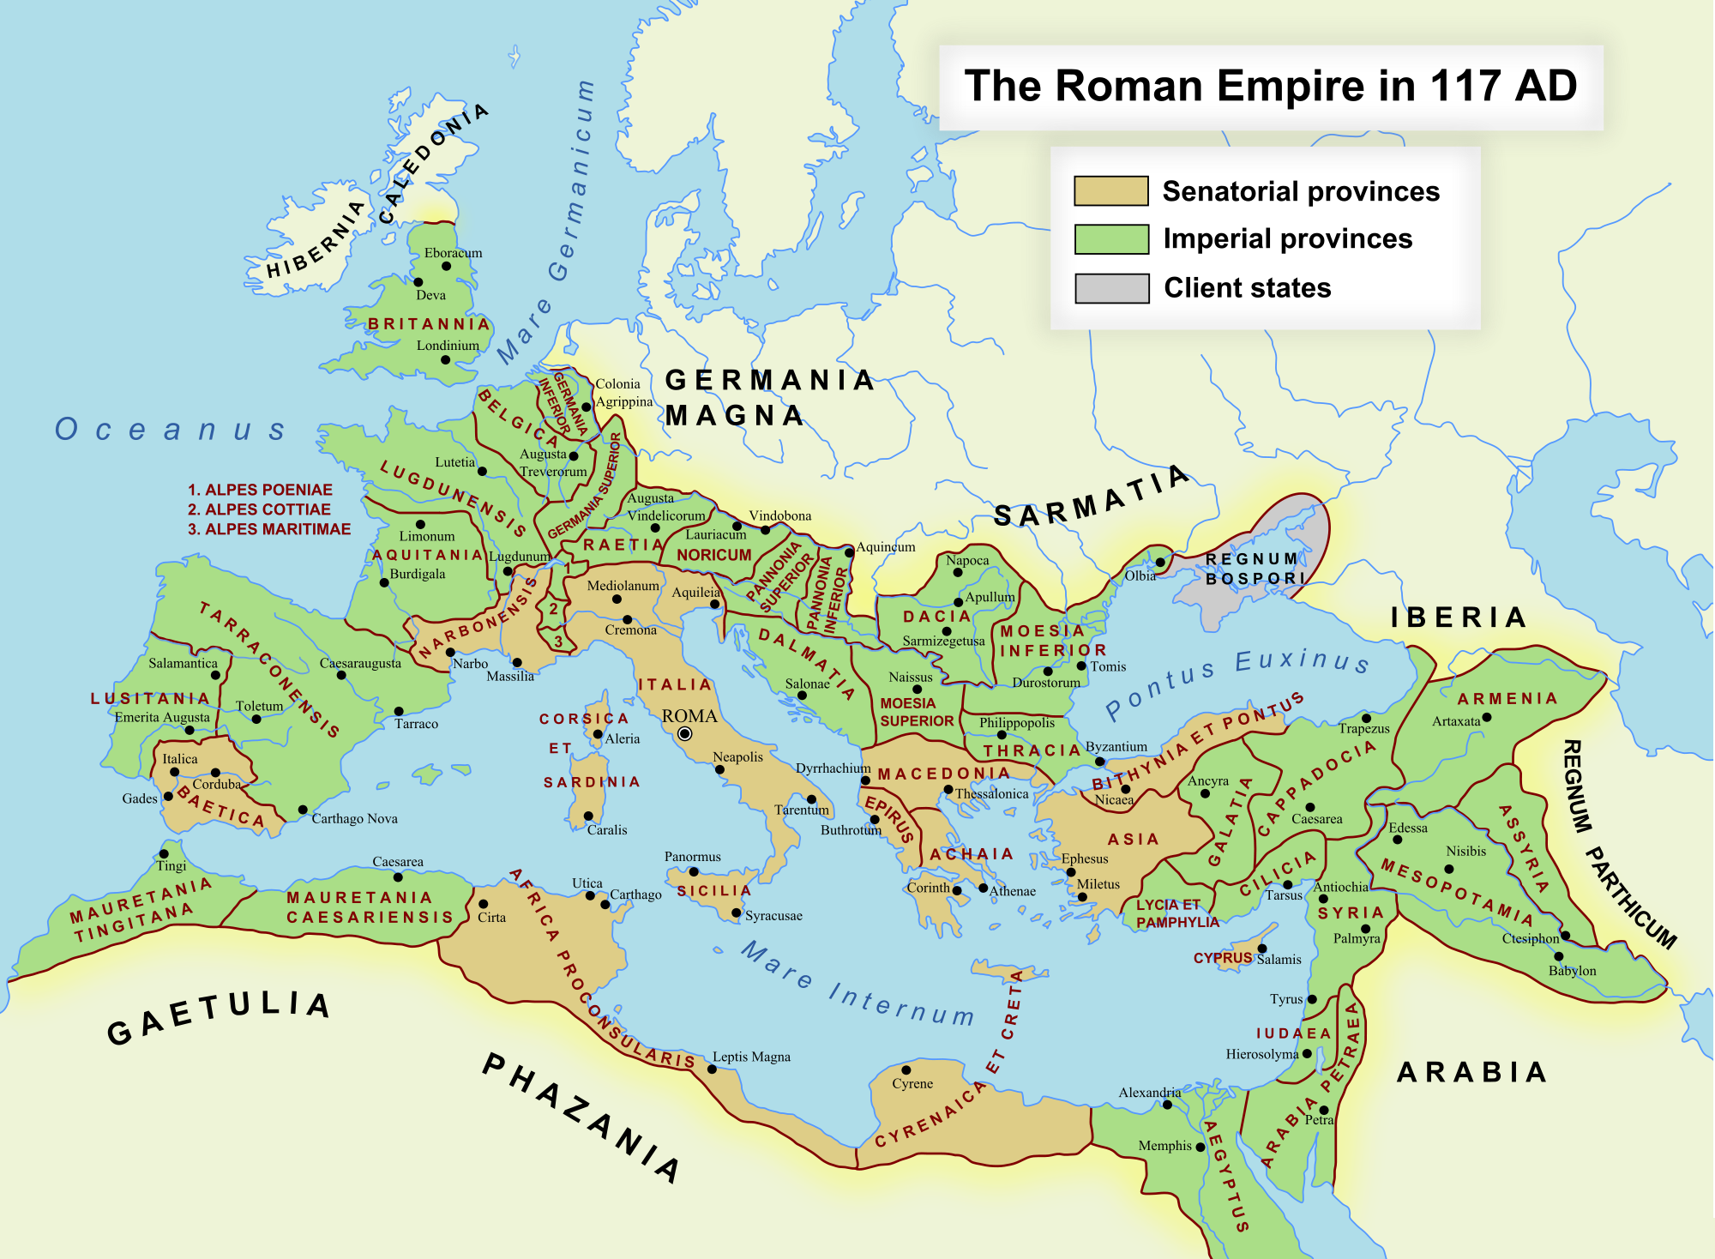
Computing - This term we will learn how computing programmes can support us in other areas of the curriculum and help us to present our work- some will be linked to our artwork.
P.E. - This term we have two outdoor sports, athletics and rounders. We will be focussing on agility and speed and throwing with force and accuracy.

French – This term Madame Whitty will teach the children about foods and in particular Ice creams and fruit.
Music- Drawing on different pieces of music, as well as varying styles of movement, children will discover how the abstract nature of music can be analysed and experienced.

History
We will recap previous history periods studied on a timeline and introduce the Roman Empire timeline.
We will learn about the Roman Empire and the power of its army and the role of the soldier. We will learn about conquest and how
It affected the British people and how their lives were changed. Finally, we will learn how Boudica and her tribe fought back.
Puma Class
Roaming Romans
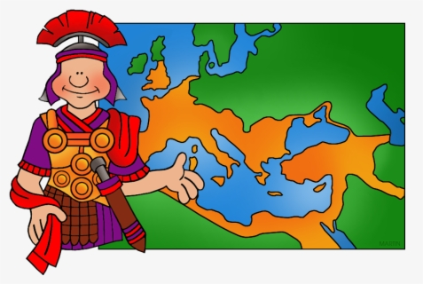 Summer 1

P.S.H.E
This term the children will be focussing on friendships. Learning how to make friends and to care for a friend when hurt or upset. They will create a web of happiness, incorporating friends and family and all that makes them important.

English
This term our class text is ‘We are the Romans. Through this fun non-fiction text, children will find out about famous Roman characters and apply what they learn to write a biography. They will explore the key textual and structural features of a biography by comparing different non-fictional texts and independently practicing these features.
We will also look at the non-fiction book ‘So you think you’ve got it bad!’ to further support our topic learning about the Ancient Romans. Children will create a non-chronological report to show case their learning, considering how to order and organise their facts most effectively for their chosen audience. We will continue to practice our spellings and handwriting in separate daily sessions.

Art
This is a multimedia topic. We will be focussing primarily on Roman mosaics and in particular, ones which depict the portraits of Roman people.
We will experiment with different media including collage and digital imagery.
We will also draw from observation, showing facial expressions and accurate facial features.

Science
In science we will be remembering the parts of plants and learning more about the function of each part.
We will focus longer on the life-cycle of a plant and look in new detail at the pollination process.
This will all take place in practice as well as theory- so keep an eye on our garden!
Maths
This term we will return our focus to fractions, where we will be learning to add and subtract fractions, as well as how to find unit and non-unit fraction amounts of a set of objects. We will then spend some time building on our knowledge of money from Year 2, looking at converting amounts into pounds and pence, adding and subtracting amounts and calculating change. We will finish the half term developing our time-telling skills. As well as finding out about the Roman Numerals to 12, the difference between am and pm, years, months and days, we will be looking at reading times on a digital clock. We will be spending time focusing on telling the time on analogue clocks to 5 minute and 1-minute intervals. Practicing this at home would be helpful!

